|  |  |
| --- | --- |
| https://camo.githubusercontent.com/07e9a91350c2a837becd6da9a0fd148ae6eab04a/687474703a2f2f646f632e676f6c642e61632e756b2f7e7774797a693030312f62616e6e65722e706e67  **Project Proposal** | Omid Ayobee  Marcell Batta  Roland Dan  Saifur Rahman  Kevin Roditi  Abul Siddique  Wojtek Tyziniec |

Introduction 3

Data gathering and requirements 4

Stakeholders 5

Market research 5

Personas 8

Potential user base 13

Competitors 15

Usage of QR codes in food industry 17

Customers perspective on QR codes 18

Standards and constrains of a QR code 18

Functional specification 19

Consumer Mobile App Use Case Diagram 20

Non-Consumer Mobile App Use Case Diagram. 21

Website Use Case Diagram 22

Full Class Diagram 23

Sequence Diagram for Customers 24

Sequence Diagram for Company Owners 25

State Diagram for Customers 26

State Diagram for Company owners 26

Collaboration Diagram for Customers 27

Collaboration Diagram for Company Owners 27

Technical architecture 28 - 36

Evaluation plan 37

Security and Computer Misuse Act 1990 37

Functional requirements (table) 39 - 43

Food organization details: 44 - 45

References 46

**Introduction**

The software project group N will manage the front end and backend of the application.

Any person that goes to supermarkets, markets and restaurants will be interacting directly with end product.

Our potential clients for the front input of the information will be farms slaughterhouses. Their input will be the information of how, where, the fruits, vegetables and meat were produced and when those would have been packaged and sent.

Middle input are warehouses and places where the different products will be dispatched.

End input will be the supermarkets, markets and restaurants.

After this process any buyer will be able to scan the QR code and know exactly where the food has been, where it comes the date and visual trajectory, this will allow users to have a peace of mind on whether the products are satisfactory and allows them to compare amongst other competitors.

Aside from competitor organisations other key stakeholders will consist of companies such as Fairtrade, by implementing our application it will allow suppliers in this case farmers to be treated honourably. As with the detailed analysis of how the products were produced it differentiates it between other suppliers, providing a more valid reason to be sold for more. This works both ways as supermarket chains are then able to identify and compare suppliers amongst one another.

World fair trade organisation being one of the biggest companies to help create a justified resolution amongst suppliers and supermarkets, would be another valued stakeholder as one of the main goals for this project was to help tackle this situation in particular. By displaying information to the end user, it will help spread the word.

**Data gathering and requirements**

**Stakeholders:**

Any person that goes to supermarkets, markets and restaurants will be interacting directly with end product.

The software project group N will manage the front end and backend of the application.

Our potential clients for the front input of the information will be farms slaughterhouses. Their input will be the information of how, where, the fruits, vegetables and meat were produced and when those would have been packaged and sent.

Middle input are warehouses and places where the different products will be dispatched.

End input will be the supermarkets, markets and restaurants.

After this process any buyer will be able to scan the QR code and know exactly where the food has been, where it comes the date and visual trajectory, this will allow users to have a peace of mind on whether the products are satisfactory and allows them to compare amongst other competitors.

Aside from competitor organisations other key stakeholders will consist of companies such as Fairtrade, by implementing our application it will allow suppliers in this case farmers to be treated honourably. As with the detailed analysis of how the products were produced it differentiates it between other suppliers, providing a more valid reason to be sold for more. This works both ways as supermarket chains are then able to identify and compare suppliers amongst one another.

World fair trade organisation being one of the biggest companies to help create a justified resolution amongst suppliers and supermarkets, would be another valued stakeholder as one of the main goals for this project was to help tackle this situation. By displaying information to the end user, it will help spread the word.

In order to keep the trust of their customers and full transparency any place that sells food would acquire this application.

**Market research**

Throughout market research, we have listed our stakeholders and email them with a proposal. (Ticked names have replied).

List of food organisations:

* --Quality assurance international
* --Foods standard agency
* --European food safety authority
* --Global food initiative

List of farmer's market in London:

* --Blackheath farmers market
* --Brixton Farmers market
* --Balham farmers market
* --London farmers market
* --Islington farmers market
* --Growing communities' farmers market
* --Wimbledon farmers market

List of farms in UK:

* --Surrey Docks farm London ✅
* --Organic farm foods ✅
* --GrowUp urban farms ✅
* --Doves farm foods ltd ✅
* --S & A Produce (UK) ltd ✅
* --Cobrey farms ✅
* --Heart of England Farms ✅

List of "Halal" slaughterhouses in UK

* --One stop halal limited
* --Adros
* --Dunbia dungannon
* --Gafoor Pure halal
* --H R Jasper & Son ltd Botathan
* --Randall parker foods
* --Rhug Estate ltd Rhug organic

List of Abattoir in UK

* -- P.C Turner
* --T & H Lobb ltd
* --C Snell Wholesale Butchers ✅
* --G & G.B Hewitt Ltd
* --Tideford Abattoir
* --Lockerbie Abattoir
* --Sandyford Abattoir (Paisley) Ltd
* --Newman’s Abattoir in Farnborough, Hampshire (more than 300 customers) ✅

**Personas:**

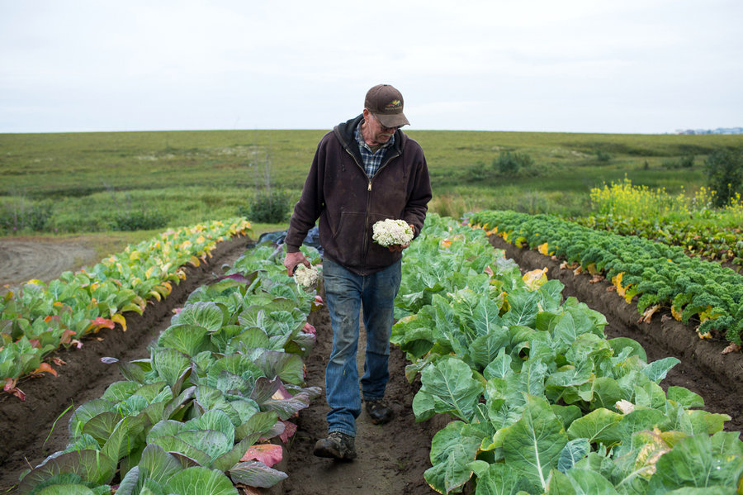

**Name:** Albert Jones

**Occupation:** Farmer

**Age:** 56

**Location:** Yorkshire

**Tier:** Master Farmer

*Introduction:*

Albert is a farmer that has been farming for his whole life and specialises in farming high quality grass fed cows. He is very dedicated to his farm where he also grows root vegetables and sells his products to the local grocery and butchers.

*Goals:*

Albert has a been breeding grass fed cows for a very long time and is trying to expand his business and customer base. He believes his cows are high in value due to the way he farms them. He has advertised his farm online but wants people to be more aware of what he does in his farm and the quality of his products.

*Targets and motivation:*

* Constantly increasing the quality of his products
* Make people aware of the quality of his products
* Be more technologically active
* To get payed the proper value for his products and possibly expand his business to have more customers

*Dislikes:*

* Albert dislikes the direction farming is going such as mass farming and believe its damaging the essence of farming and quality of food being sold to the public.
* He also dislikes companies trying to rip farmers off.

[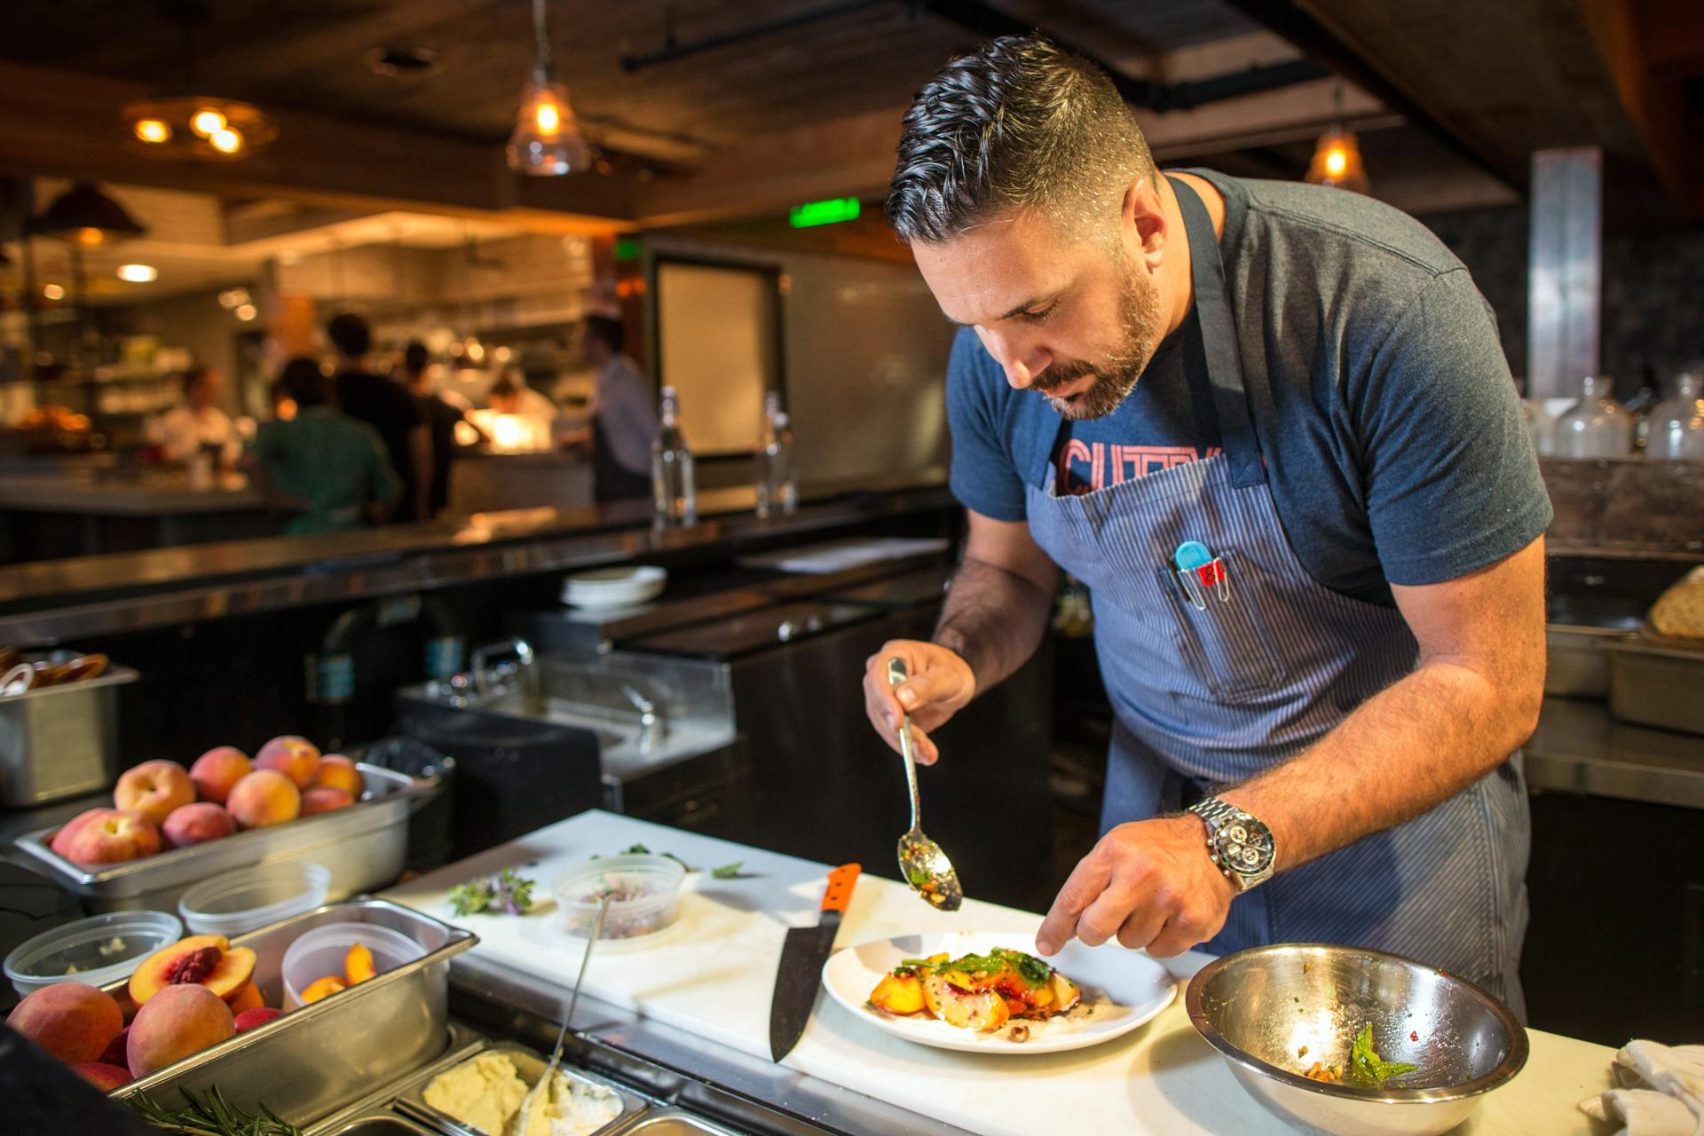](https://camo.githubusercontent.com/e7b809fc210edfdc4847ce6a9f19cf16ed17a9dc/68747470733a2f2f692e70696e696d672e636f6d2f6f726967696e616c732f38392f35642f61302f38393564613037633632323463643461646433383865636131386234326237362e6a7067)

**Name:** Wilson McKenzie

**Occupation:** Store/Café/Restaurant Owner

**Age:** 29

**Location:** London

**Tier**: Owner/Manager

*Introduction:*

Wilson is a young entrepreneur whose opened his own grocery store where he sells high quality organic grocery products sourced from local area and believes that local small businesses should help each other and offer better and healthier products to local communities.

*Goals:*

Wilsons goal is to make people more aware of the products that they buy as he states all possible information available about products he sells. He’s trying to implement a better technological interaction with his customers. *Targets and motivation:*

* Promote local businesses and organic products
* Make people aware of items that they buy
* Customers that support his vision of quality and community

*Dislikes:*

* Wilson is against selling products that are not of decent quality.
* He also dislikes businesses who do not care for their customers and use mass production.
* He also doesn’t like “fake” foods which are full of chemicals and bad for your health



**Name:** Elvis Green

**Occupation:** Liberal arts student

**Age:** 22

**Location:** London

**Tier:** Hipster

*Introduction:*

Elvis considers himself a hipster. He is an independent-thinker that values counter-culture, progressive politics and has an appreciation of art, creativity, intelligence and witty banter. He rejects the culturally-ignorant attitudes of mainstream consumers He follows the latest trends and fashion especially those regarded as being outside the cultural mainstream.

*Goals:*

Eat healthy. He would rather go to a small independent shop rather than a big supermarket to buy his groceries even though he knows it’s more expensive, so he can help the small businesses. Also, he promotes healthy eating in his friend circle and always suggests what to eat and where.

*Targets and motivation:*

* Healthy eating
* He likes the warmness and friendliness of a small shop rather than a big chain where he feels more valued
* Helps local businesses and promote organic food in his community

*Dislikes:*

* Big chains and superstores
* Pollution
* Food full of artificial ingredients
* Mainstream stuff
* Trump

[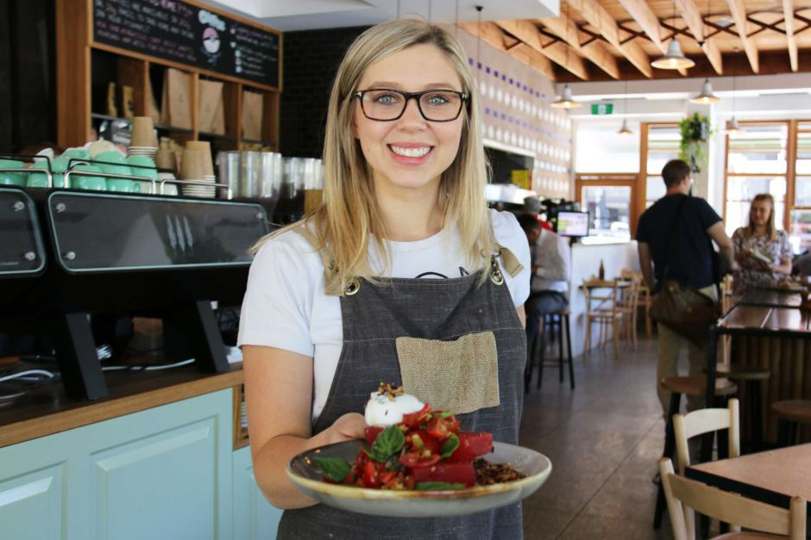](https://camo.githubusercontent.com/c9c08c1d599c78bccc355a46d670e37961cad82a/687474703a2f2f7777772e6162632e6e65742e61752f6e6577732f696d6167652f373032383034302d3378322d393430783632372e6a7067)

**Name:** Ellie Marsh

**Occupation:** Supervisor

**Age**: 27

**Location**: London

**Tier:** Hospitality worker

*Introduction:*

Ellie works in hospitality and her schedule can be busy or quiet depending on the hours she is doing every week. When she is busy she does not have time to cook so she would rather eat out or buy ready-made food. On her quiet days she’d rather go to the local grocery store and buy organic food, cook and eat at home.

*Goals:*

She would love to eat healthy but due to her schedule she does not have the time to do so. She is not really fussed about where the products are from and how are they made but whenever is in the situation to pick from 2 of the same products she always picks the organic one and the one that is fair trade. By doing this she does not feel as guilty.

*Targets and motivation:*

* Healthy eating
* She likes the friendliness of the local shops and cafes as she can chat with the owner about the products

*Dislikes:*

* “fake food”
* pork because she thinks pigs are cute
* complicated tasks, she would like to have everything at a click of a button
* lack of information

**Potential users base:**

**We have two potential user base:**

* The people who will use the app to add their products to the system at any point in their journey
* The people who will use the app to track their food

**Farmers and supermarket**   
The first group will be people such as farmers, transporters and supermarkets. They will be the ones using the app for scanning their goods' QR codes to tag the route they have taken to arrive at their destination. These people will likely have a range of technical understanding as we would be targeting more "traditional" farmers who might be less modernised than some. This means our app needs to have a simple user interface. However, to make sure that all our users can use the app to its full effect, it might require some training maybe in the form of videos or manuals inside the app. Transporters and supermarkets will have a much smaller job compared to the farmers themselves as that is where most of the information about the products will have to be entered.

**Standards and contrains of QR code**

There are various types of constraints that will restrain the idea itself, first being the initial concept of the idea for QR code requires the users using the software to have a mobile device or tablet that has a working internet connection for the scanning to work, as once the code is scanned and decrypted it searches the nessesary web address and diverts you accordingly. A possible solution to overcome users not having access to internet is being able to save QR codes to scan later when connection arises which can be stored in a possible history section with in the app itself.

Furthermore, majority of the time scanning a QR code is very efficient as long as a valid internet connection is available however due to various different devices which are used across the board details such as lighting and quality of the camera being used must be taken into consideration, in order to make this process more efficient and not put users off scanning the item. In such cases where the lighting isn't adequate an option within the app to turn any available camera flash light would be appropriate. In addition, considering the size of the QR code is another factor. If the size of the generated QR is that of 250x250 which is slightly larger than most commonly used codes it would allow ease of scanning and would be another solution for users with lower end devices this would not only benefit consumers but it would also mean that farmers or companies associated with transport means would find it much easier and would not require high end equipment.

Also a beneficial use of using web analytics, and by using unique codes for different placements, marketers can gain some valuable information about how well campaigns are going, and what works and what doesn't. Once a QR code is scanned, using that information we can identify which products in what prime locations are popular. This could potentially be fed back to manufacturers and business if users are happy with sharing this information and as long as it abides by the regulations.

Besides the different acts of the misuse of a computer, we could find problem on the actual definition. Misuse per definition is to use something in the wrong way or for the wrong purposes.

**What is a QR Code:**

QR codes are two-dimensional quick response codes that are now gaining notability and popularity in the United States. They are easy to use and versatile. The code itself stores huge amounts of information that is easily scanned and stored onto a mobile device. Many businesses are now adopting this code as a means of marketing and as another way to attract customers to the internet for more information. QR codes have both advantages and disadvantages and both benefits and drawbacks of the code should be understood before using the QR code as a marketing technique.

**Problems we could encounter with the use of QR codes are:**

* --Losing the stamp
* --Various aliments or crates will be stored in either cold temperature rooms, fridges or hot rooms, therefor the condensation could alter the QR code. Without saying unstick the sticker.
* --Moving the said merchandise, scratched or marks could be damaging the sticker
* --Distortion of an enlarged QR Code may be difficult or impossible to read it
* --If letters or pictures are placed around a QR Code, the required margin cannot be secured
* --If you place letters or pictures on an area overlapping a QR Code, the contrast between the bright and dark areas becomes indistinct. This kind of code is difficult or impossible to read.
* --The other problem that many users have with QR is that it simply doesn't work very well. For a code to scan well it needs to be done it good light, on a high contrast background

Also, we have to ask ourselves, what would happen to the merchandise if we lose/damage the QR code, do we throw away the merchandise, would that be politically/ethically correct? (needless to say, loss of profit)

**Other disadvantage of QR Codes:**

One disadvantage of QR codes and perhaps the biggest problem is the lack of familiarity of the QR code among people. Although QR codes are popping up everywhere from on plant specimen labels to library catalogues, there is a large demographic in society that still don't know what QR codes represent. These proses a problem as companies and business are using the QR code to advertise information that a potential customer might be interested in, but if the customer doesn't know how to find the information, then they might not buy the product or service, this can lose business thousands of dollars. One way to counteract this disadvantage is product knowledge. Not only should businesses be using QR codes for it's obvious benefits and advantages, but they should also be directing customers on where and how to get the information. Another major disadvantage of a QR code is the codes dependability on a mobile device or smartphone. The whole concept of a QR code and its benefits are strictly based on its ability to be scanned by a mobile device. If a consumer does not have a mobile device or smartphone, then the QR code is not beneficial to them and they lose out.

**A good solution could be to 3D print the QR code**

Smooth concrete works fine, uneven concrete is hard. Steel girders, smooth walls, painted walls, painted floors, tile, board, tables, plastic, paper all work well

**Competitors:**

Who are our main competitors and what app existing on the market?

Having search the web for competitors and already existing applications, the result was very interesting. Not only have I searched the English-speaking market, but French and Spanish as well.

French and Spanish market apps, are more focused on the quality of the food and the "dietetic content" they have. How to find the sanest aliment, what food has the best vitamins, which food to buy for specific diets, etc. Coming to traceability of their food, no app has been found.

Interesting enough, the English-speaking community understands, not knowing where their food comes from, is a real issue. Reading a review from the website <http://www.eatingwell.com/article/10290/trace-your-food/>, we can realise that people want to know.

Searching deeper in the web, several website had either the idea or had started to create this app. This very interesting review ( <http://www.foodsafetynews.com/2013/05/putting-food-traceability-at-consumers-fingertips/#.WfXPyddl82z>), points to an Australian website, <http://kiallafoods.com.au/plate2farm/>,

that traces farm products, but so far nothing major in the performance/power of his app.

On a higher level, the food industry already uses traceability of the food they store and redistribute. Warehouses use this software, <https://www.emydex.com/software-modules/traceability-reporting/?gclid=CjwKCAjw-NXPBRB4EiwAVNRLKmtut1ZXCNTYqfGgNWzYfgGuks7bdhR0zotoTAizkKTw4z9B-1ofZRoCf3AQAvD_BwE>, that not only traces the food but does reports about it. This website, [http://www.sourcemap.com](http://www.sourcemap.com/) offers companies a Data-driven sustainability monitoring and evaluation by traceability, monitoring, verification and dashboards.

Existing application to track your food:

<https://www.provenance.org/>, uses blockchain technology to track your food, this is a quote from the BBC website (<http://www.bbc.co.uk/news/av/business-38773881/the-woman-using-technology-to-prove-where-food-comes-from>)

_"_The British company Provenance says it is lighting a fire under the retail world.

The company has developed an app that allows retailers and customers to see where a product comes from - from origin to point of sale.

"Behind every product is a complex chain of people and places, and that's a really important part of why people buy things," founder Jessi Baker explains.

"Provenance is all about making that information transparent to shoppers, but also to businesses, all along the supply chain."

<https://www.harvestmark.com/solutions.aspx>, would be another serious competitor, as their app already exists on the market.

Believe or not even McDonalds, allows you to track the content of every aliment that you have in your burger <https://www.psfk.com/2013/01/mcdonalds-food-tracking-app.html>.

Smaller but with the same concept <https://www.digitaltrends.com/mobile/buycott-review/>

**Usage of QR codes in food industry**

**Companies**   
The growing thirst for knowledge of consumers regarding their food product has concerned companies. Many big companies are looking for ways to get consumers the information they’re seeking about the food, beverage and consumer products that they use.QR codes makes it easier than ever for shoppers to find information about products they use and consume. There just isn’t enough room on packages to fit all that information. complements the way consumers shop today and enables them to get all the information they want to know about what they are purchasing – when they want to know it.

In 2015 GMA (Grocery Manufacturers Association) and the Food Marketing Institute formed to make a website called smart label. This website gives consumers information on things such as nutritional information, ingredients, allergens, third-party certifications, social compliance programs, usage instructions, advisories & safe handling instructions, company/brand information, along with other pertinent information about the product. Companies apply a Smart Label QR code on their products which then consumers can use any QR scanner app to get all the information they need or they can manually search the item on the Smart label website.More than 30 major companies which includes companies such as Nestle, Hershey, Reeses and Campbell, have already committed to using SmartLabel™.

In late 2015, Hershey became the first brand to adopt SmartLabel, as of mid-July, Hershey had seen about 47,000 QR code scans from about 26,000 unique users on the 300 products currently labeled with the QR code in stores.

Follow this food is also an website which allows customers to track and get tons of information regarding their product. Follow this food operates by giving companies a platform to advertise and promote their products. companies will have a QR code on their products and consumers can go to follow this food website and scan the QR code to get tons of information.

**Customers perspective on QR codes**   
The usage of QR codes in the food industry has mixed arguments as most consumers are for the technology but some against it.

advocates of the GMO (genetically modified organism) labelling has criticised the use of QR codes saying that grocery associations codes are discriminatory as this is a technology most consumers dont use, and a technology which might be prone to error as the codes might be unreadable due to wearing of from the product.

However According to the research most customers sees QR codes as it is a useful tool which helps consumers to get information on their products.Customers went on to say "Stickers can be displayed on food packaging, highlighting that the meat within is 100% British, but this doesn't guarantee that it has been ethically sourced or that the supply chain is sustainable. I am a truly cynical consumer; just because supermarkets put photos of their farmers on meat packages, doesn't reassure me"

Functional specification

*Figure 1: Geofood* *Consumer Mobile App Use Case Diagram.*

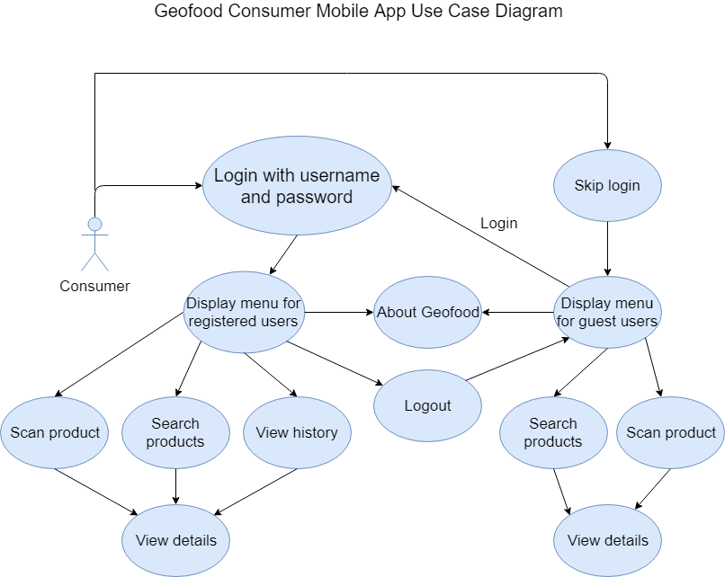

*Figure 2: Geofood* *Non-Consumer Mobile App Use Case Diagram.*

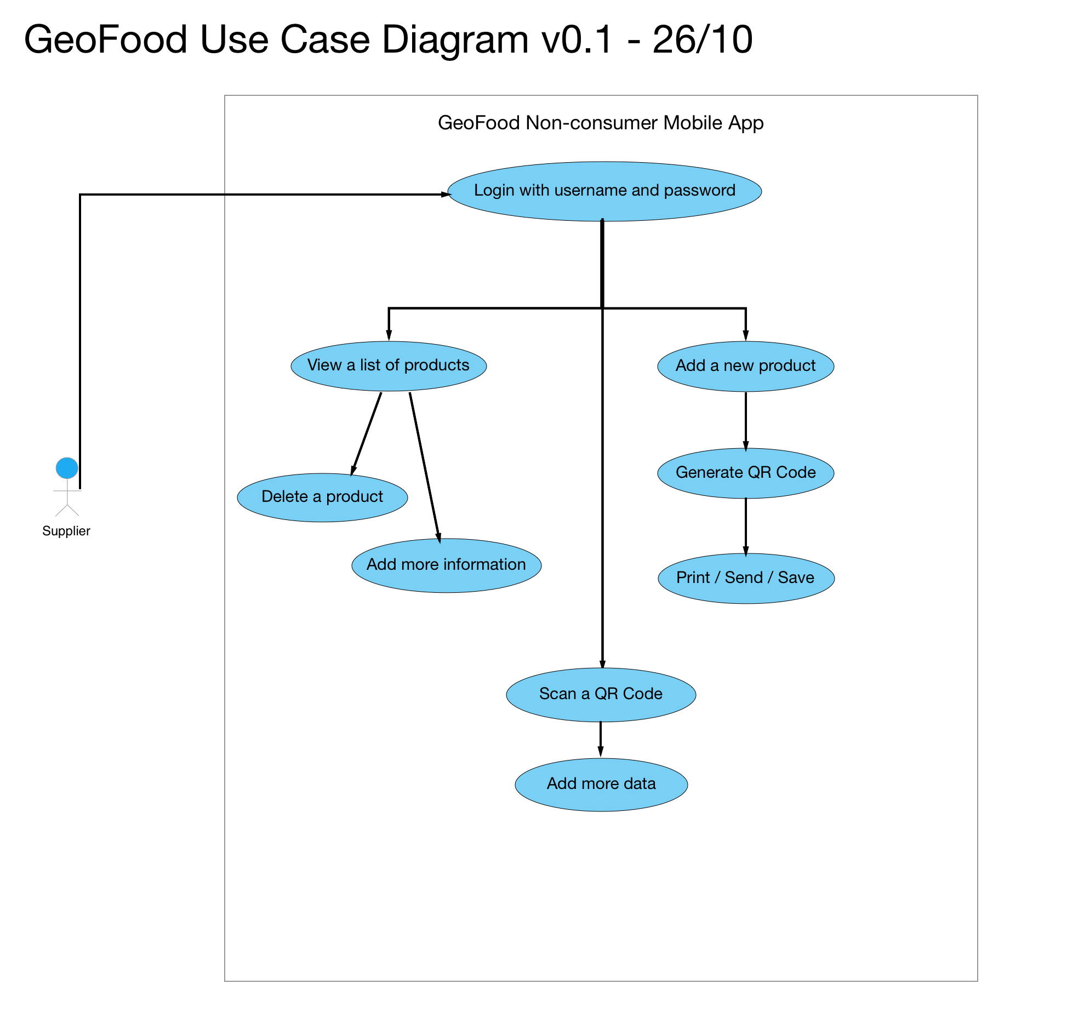

*Figure 3: Geofood Website Use Case Diagram.*

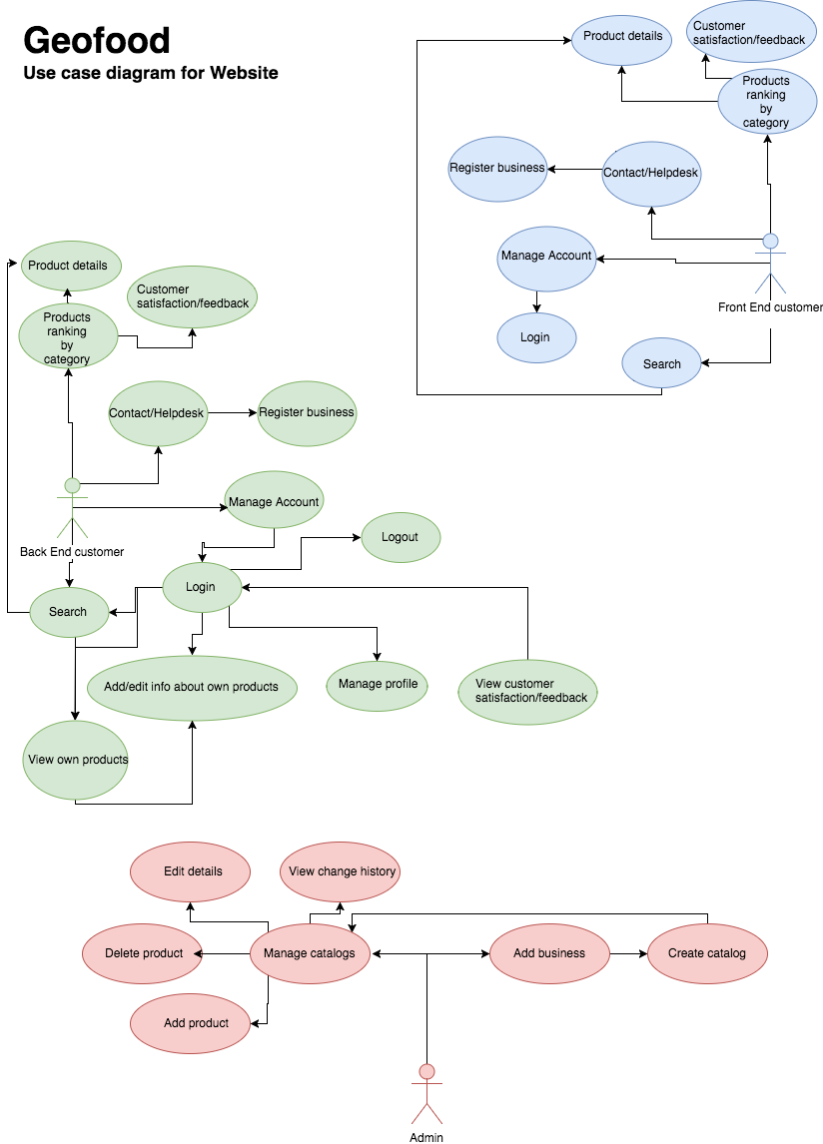

*Figure 4:* *Full Class Diagram.*

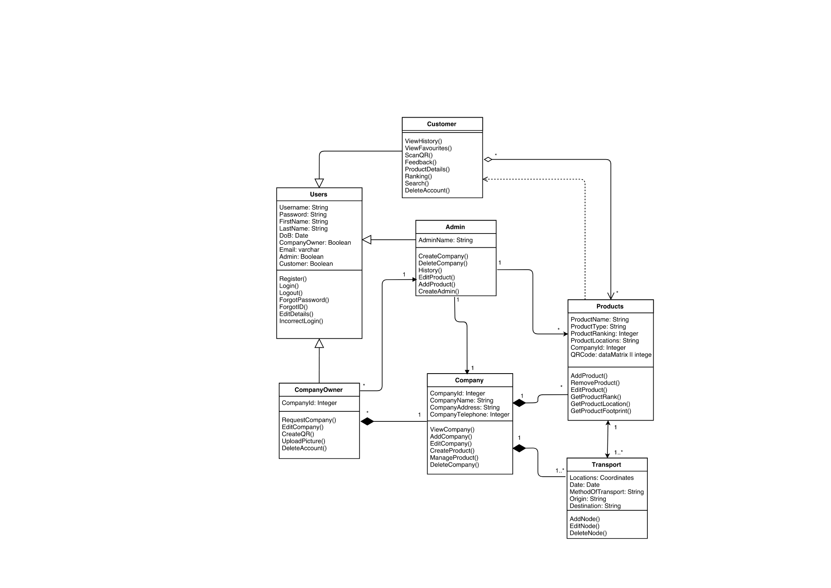

*Figure 5:* *Sequence Diagram for Customers*

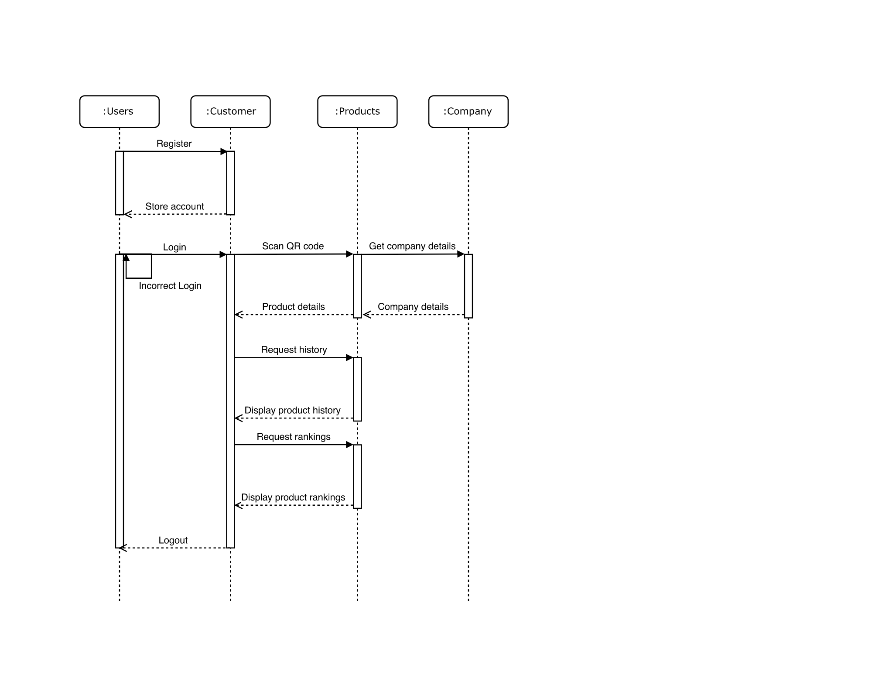

*Figure 6:* *Sequence Diagram for Company Owners.*

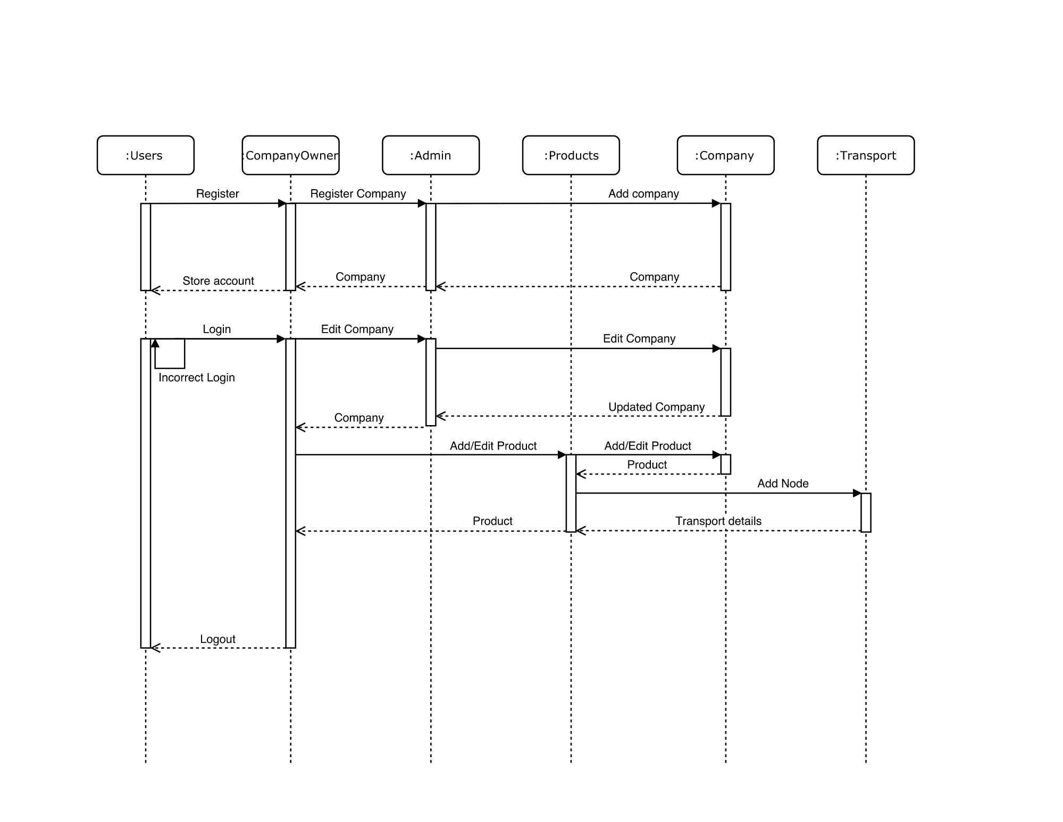

*Figure 7:* *State Diagram for Customers*

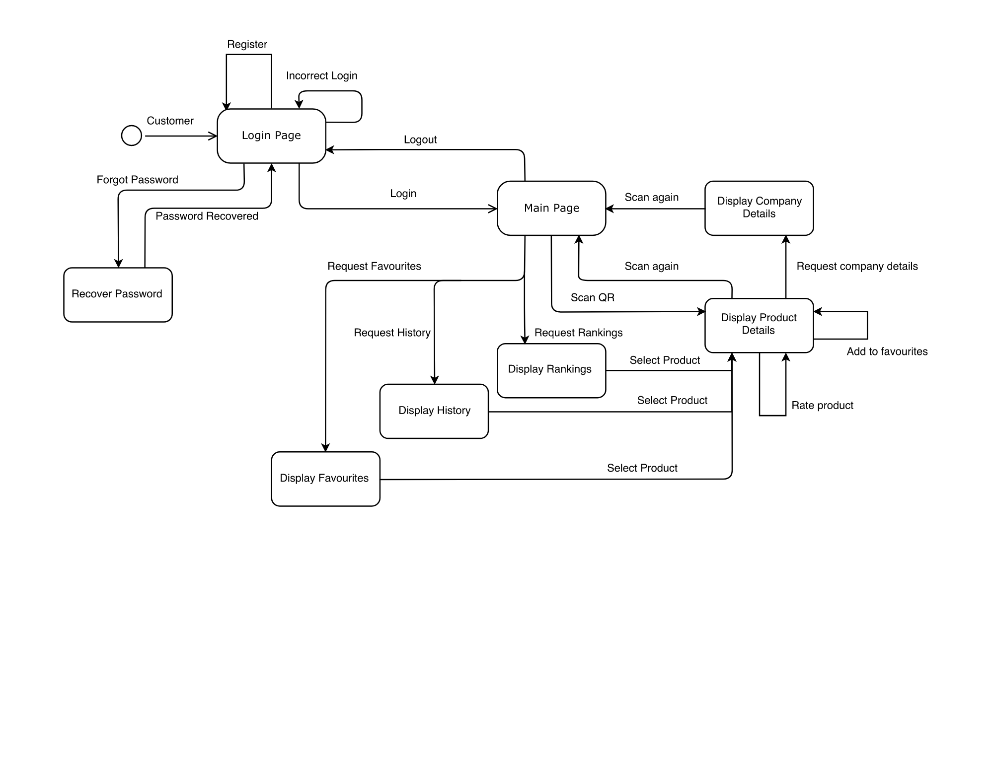

*Figure 8: State Diagram for Company Owners.*

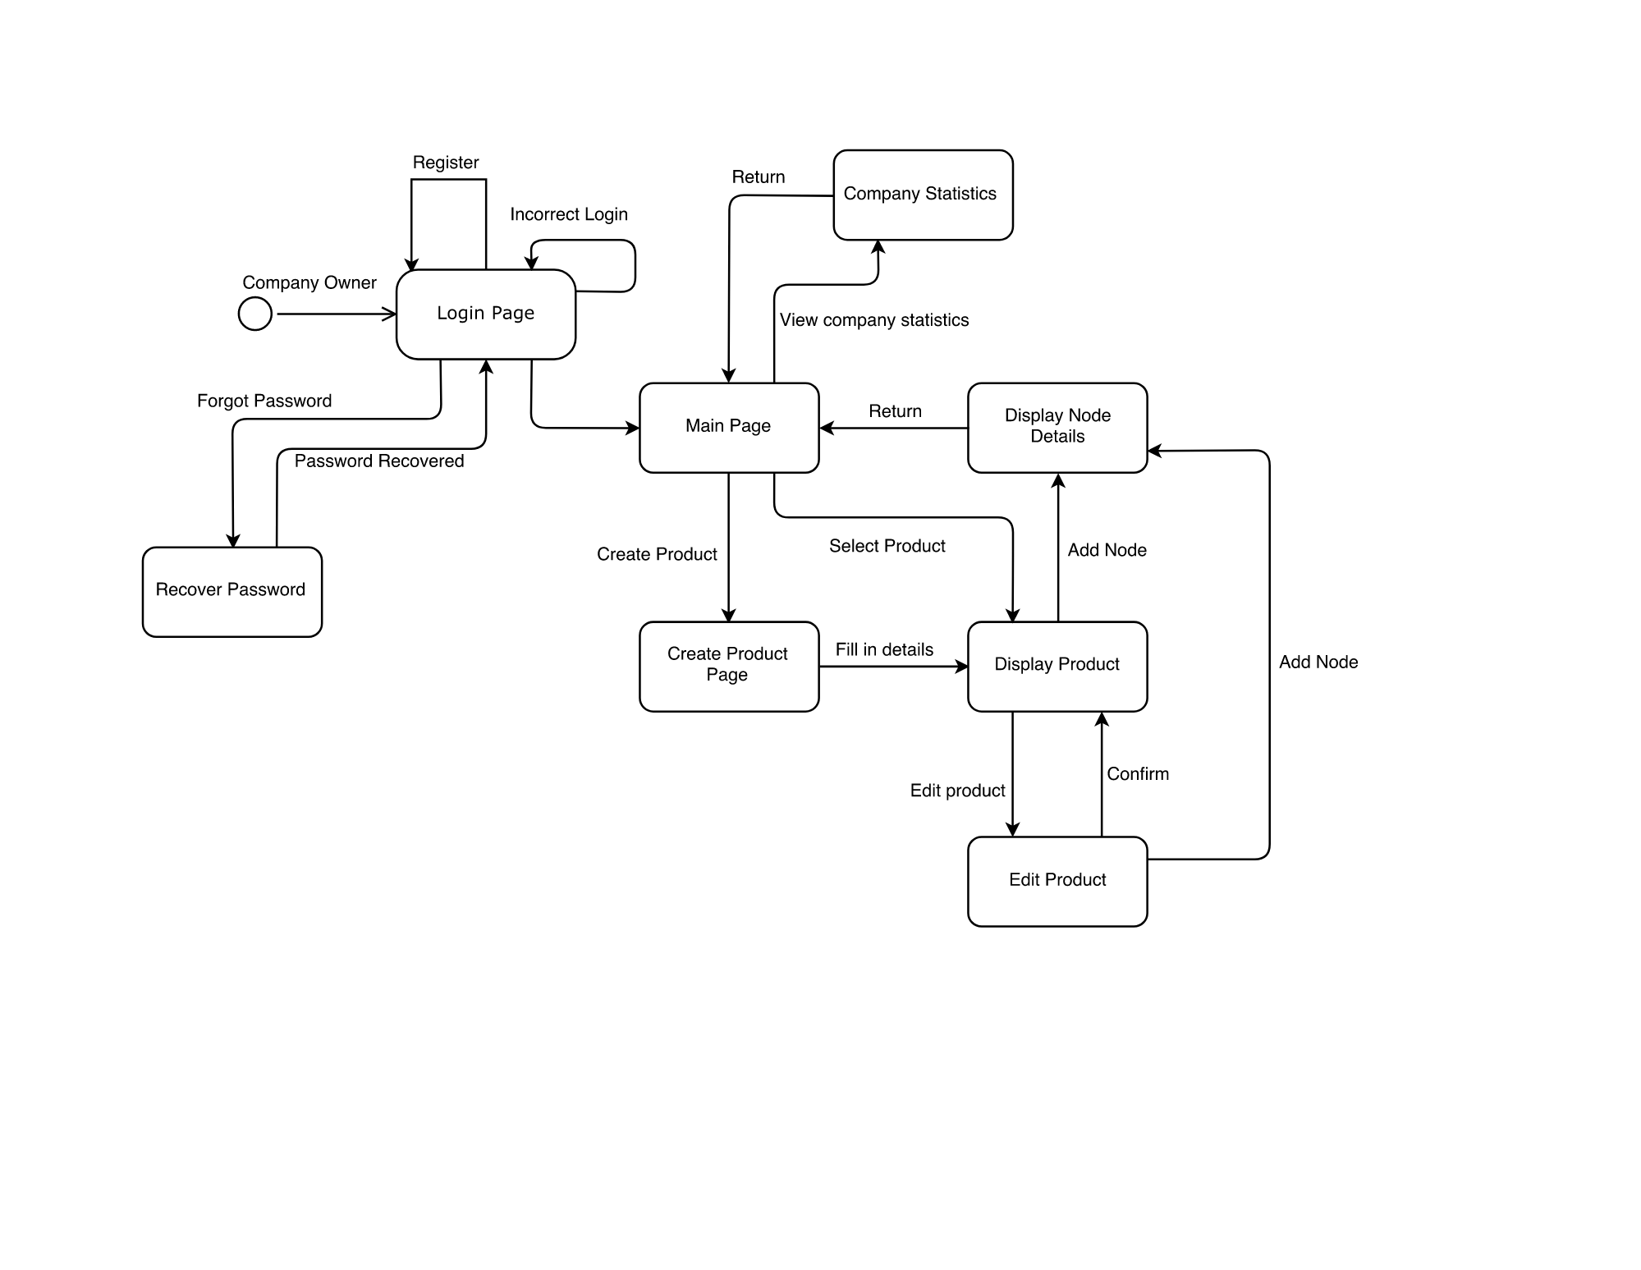

*Figure 9:* *Collaboration Diagram for Customers.* 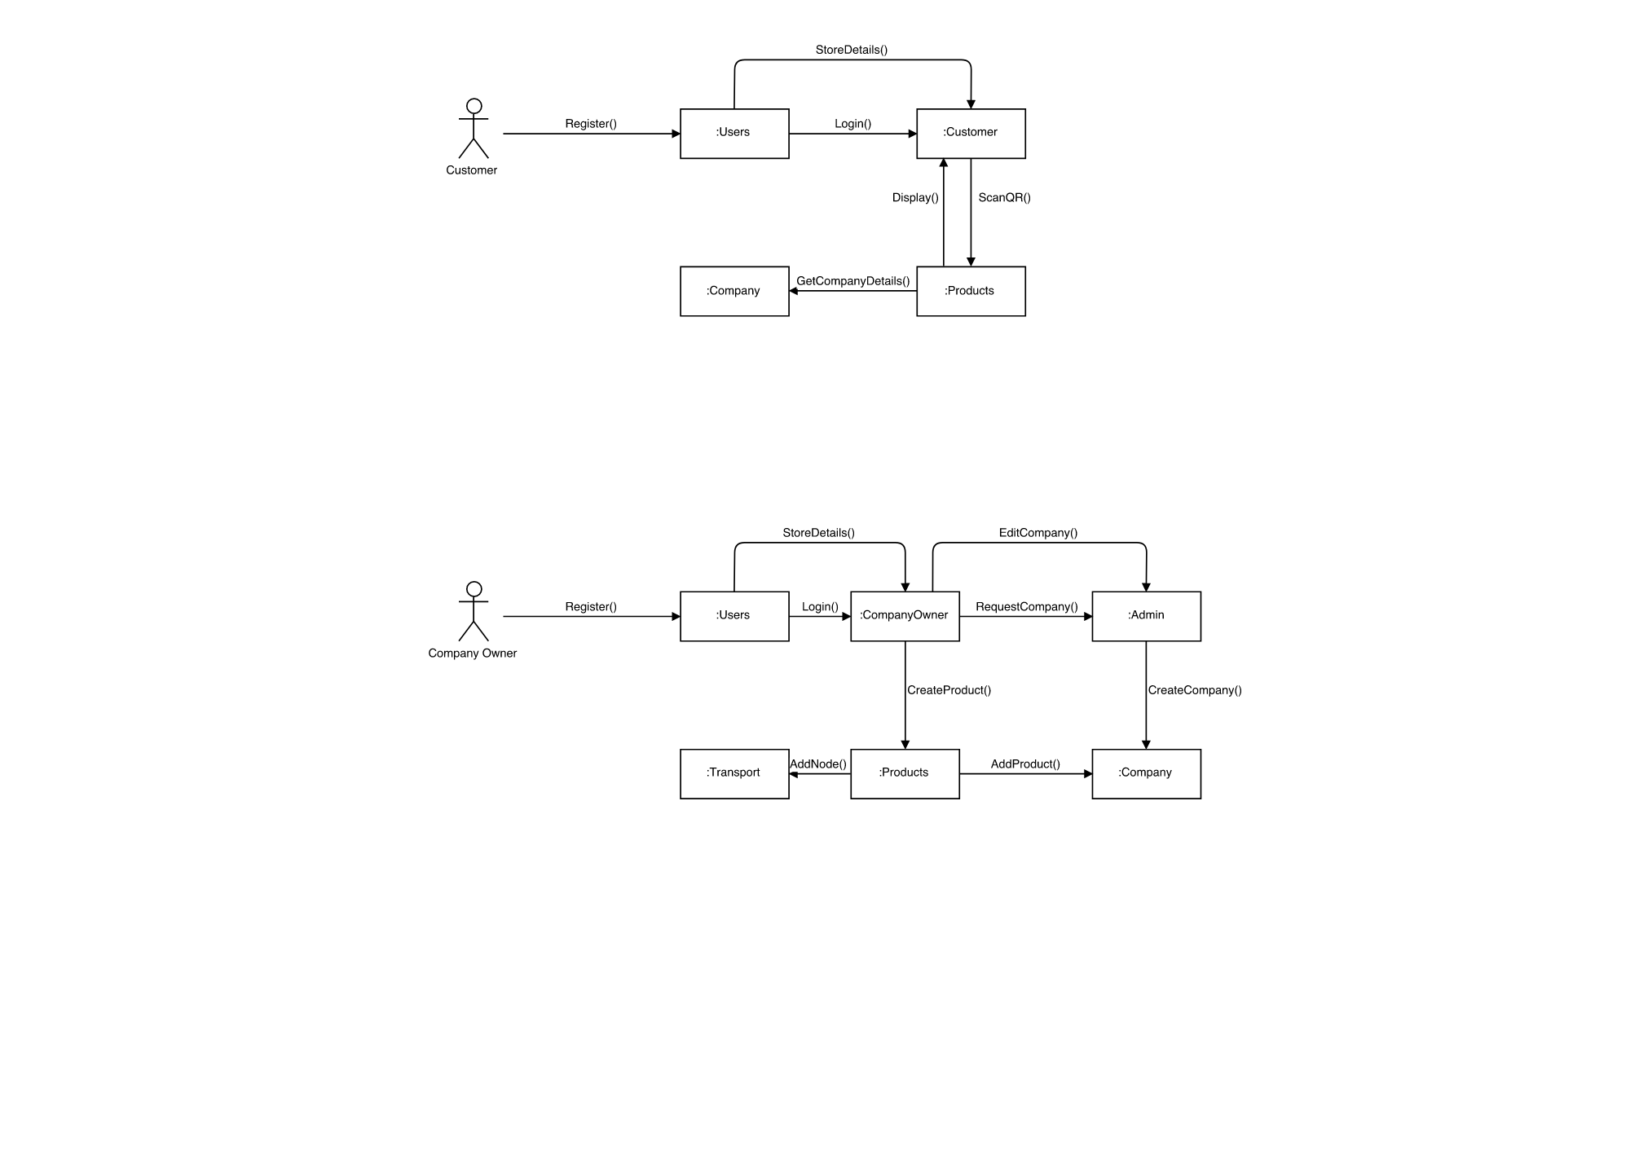

*Figure 10: Collaboration Diagram for Company Owners.* 

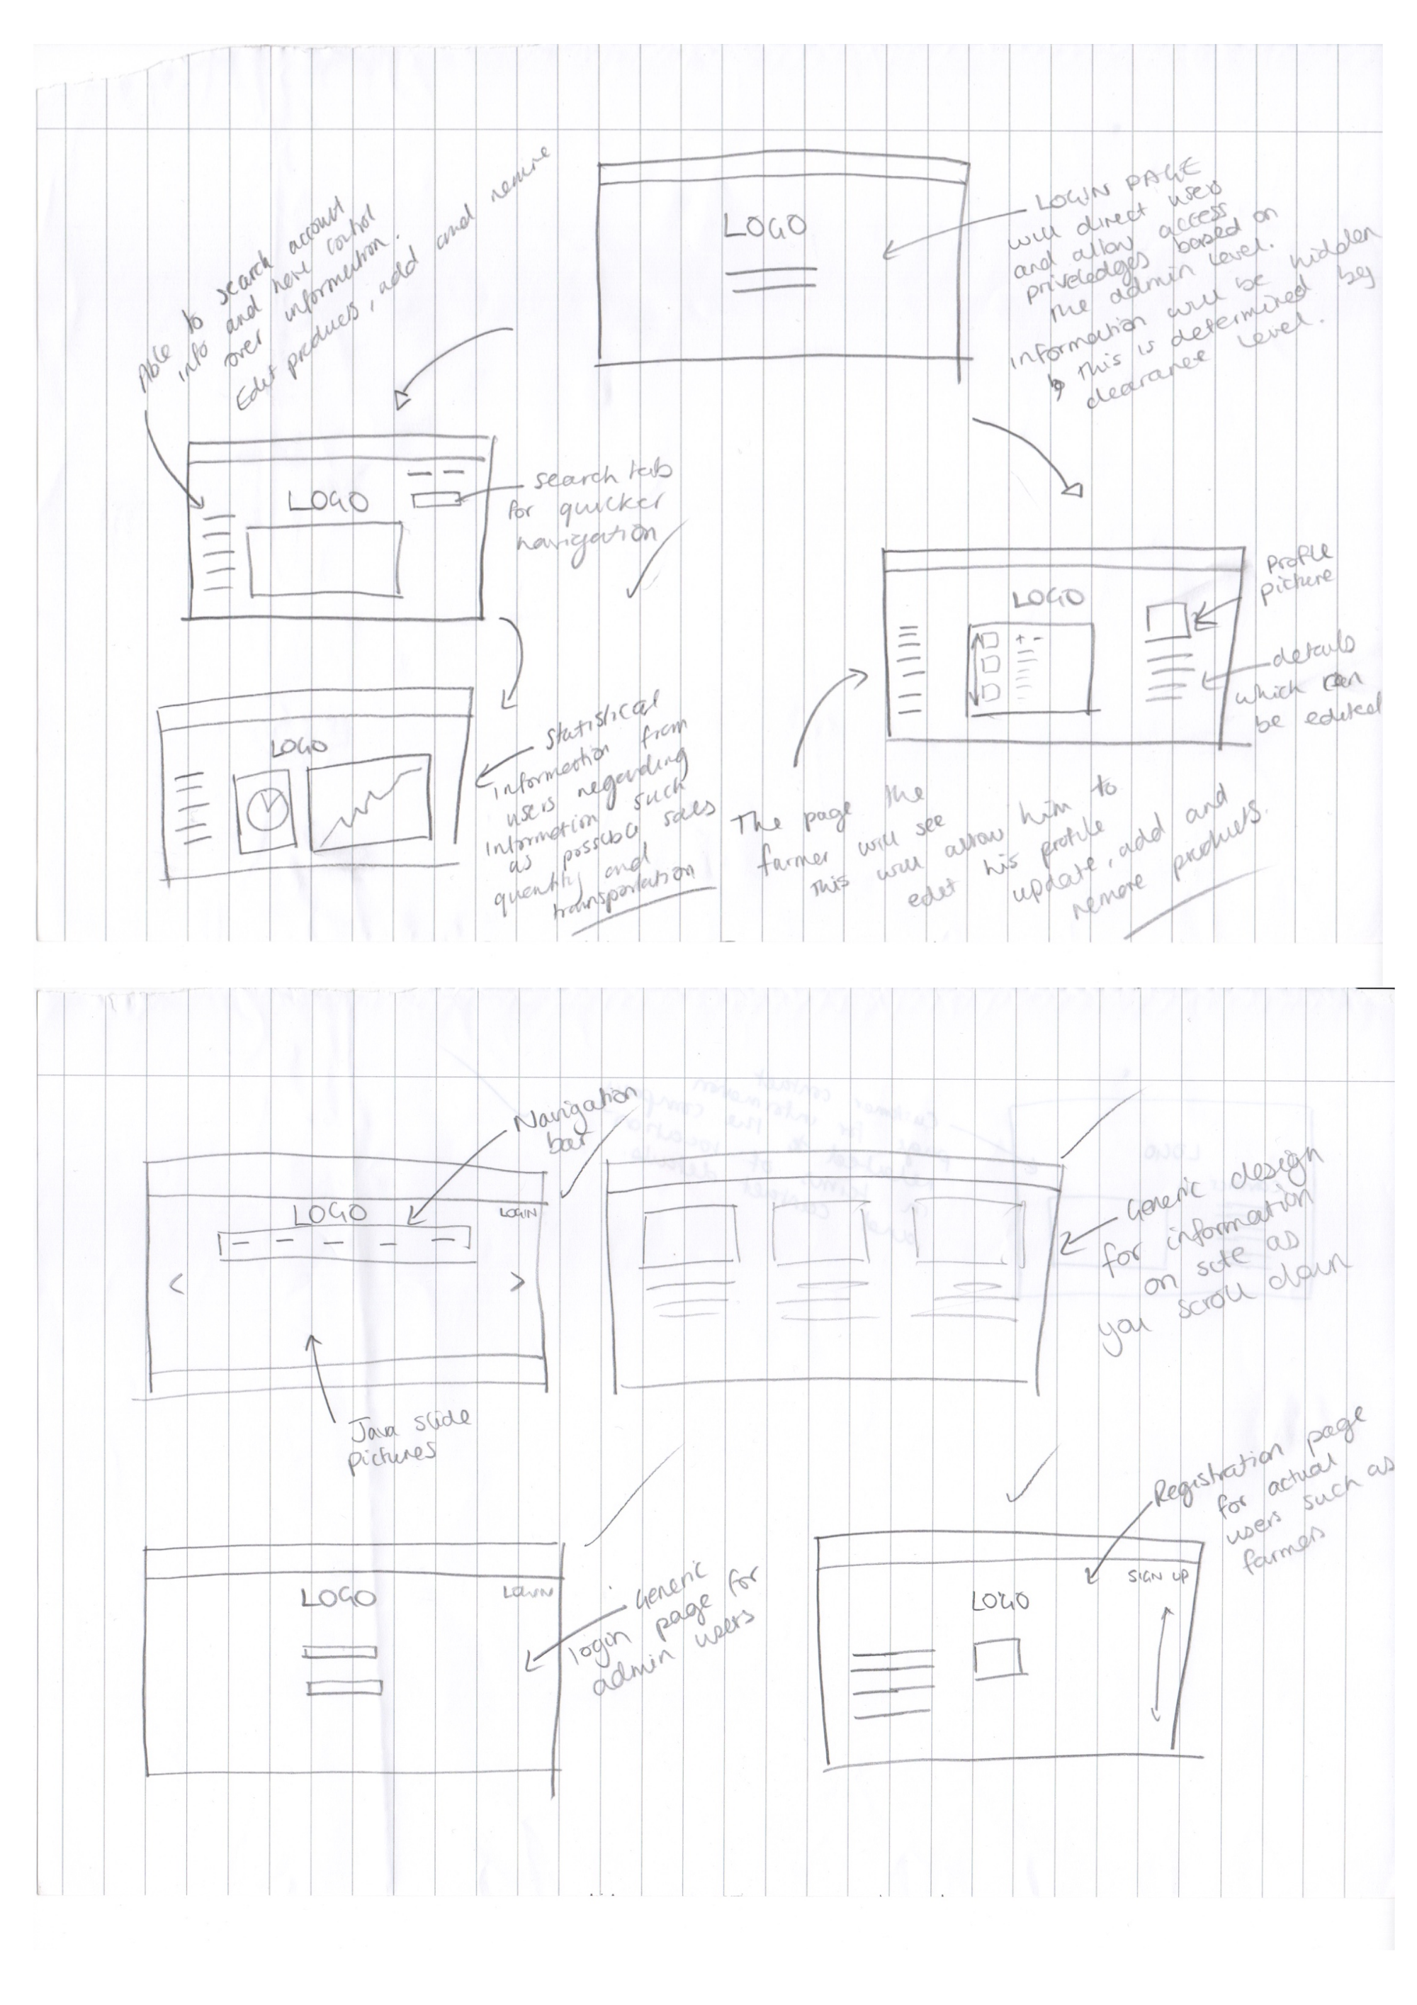

*Figure 11: Paper wireframes/prototypes of website.* 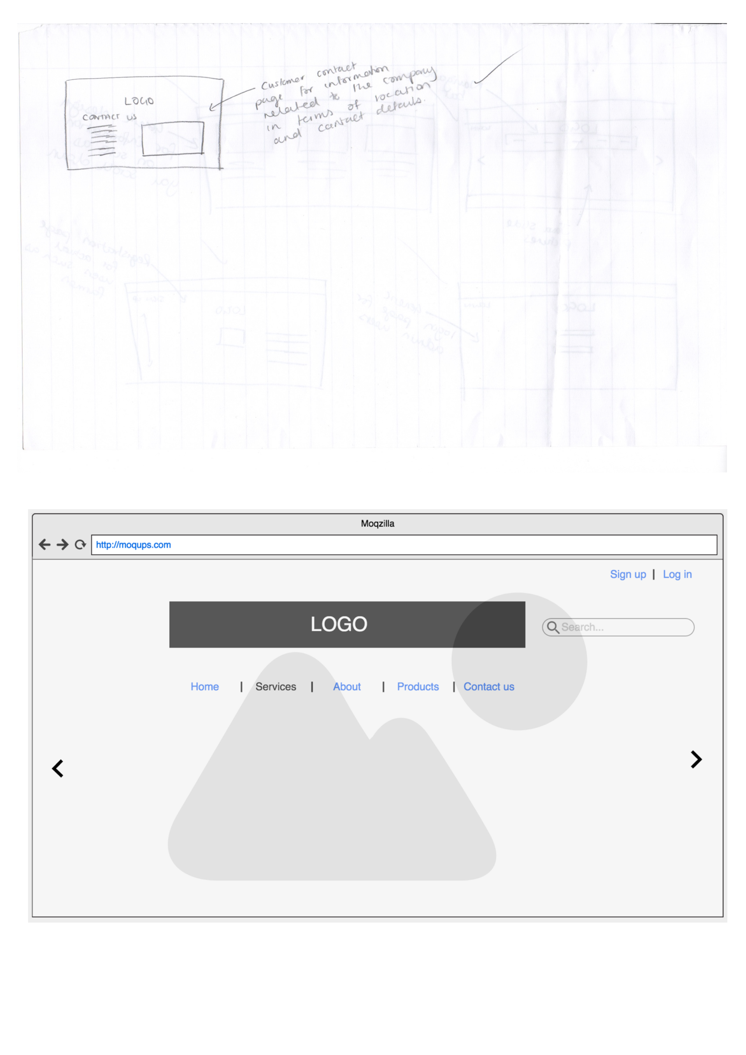

*Figure 14: Digital wireframes/prototypes for Mobile App.*



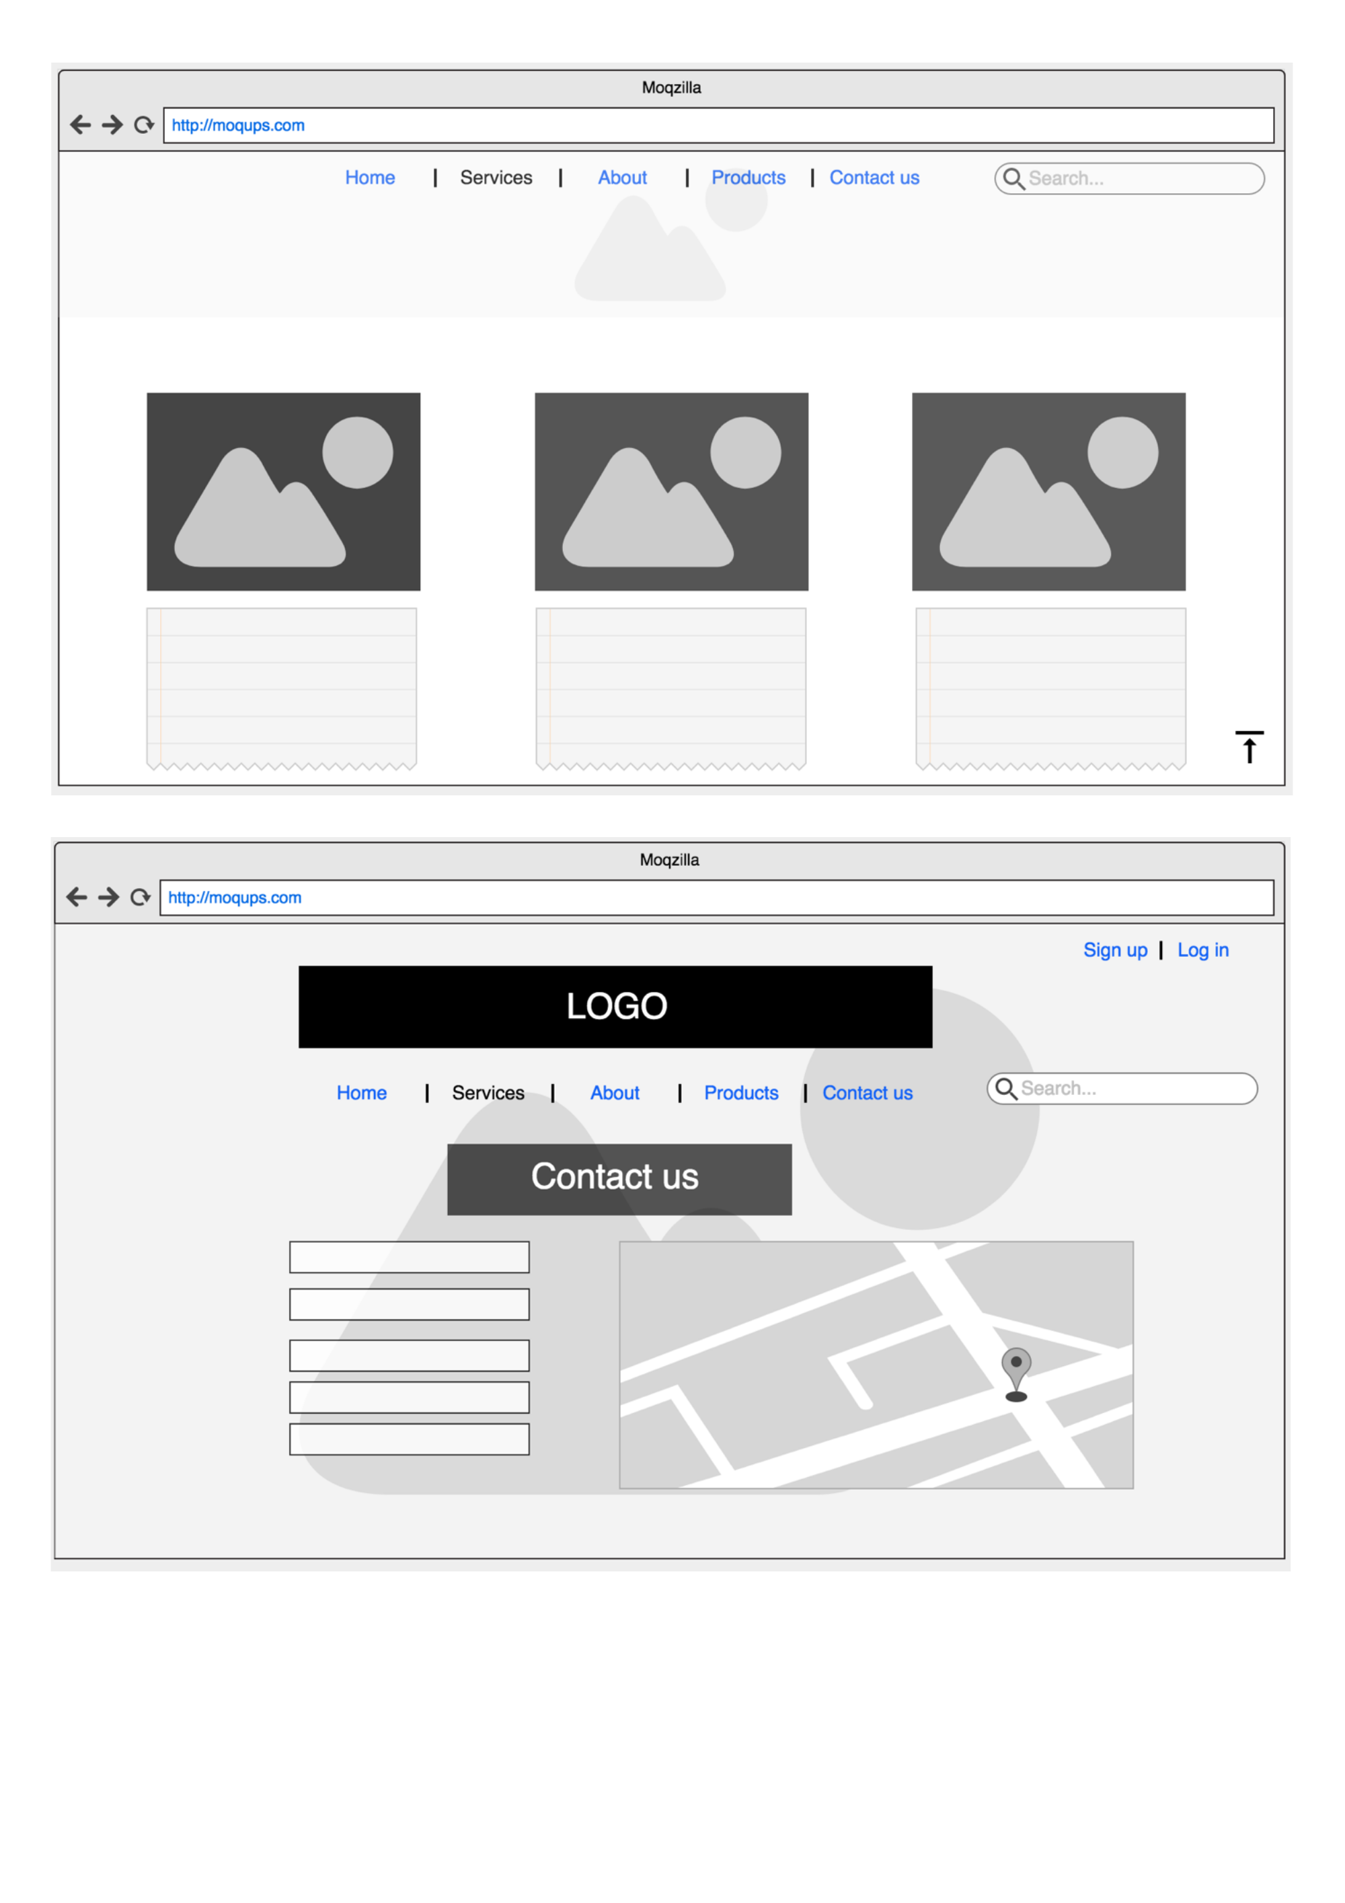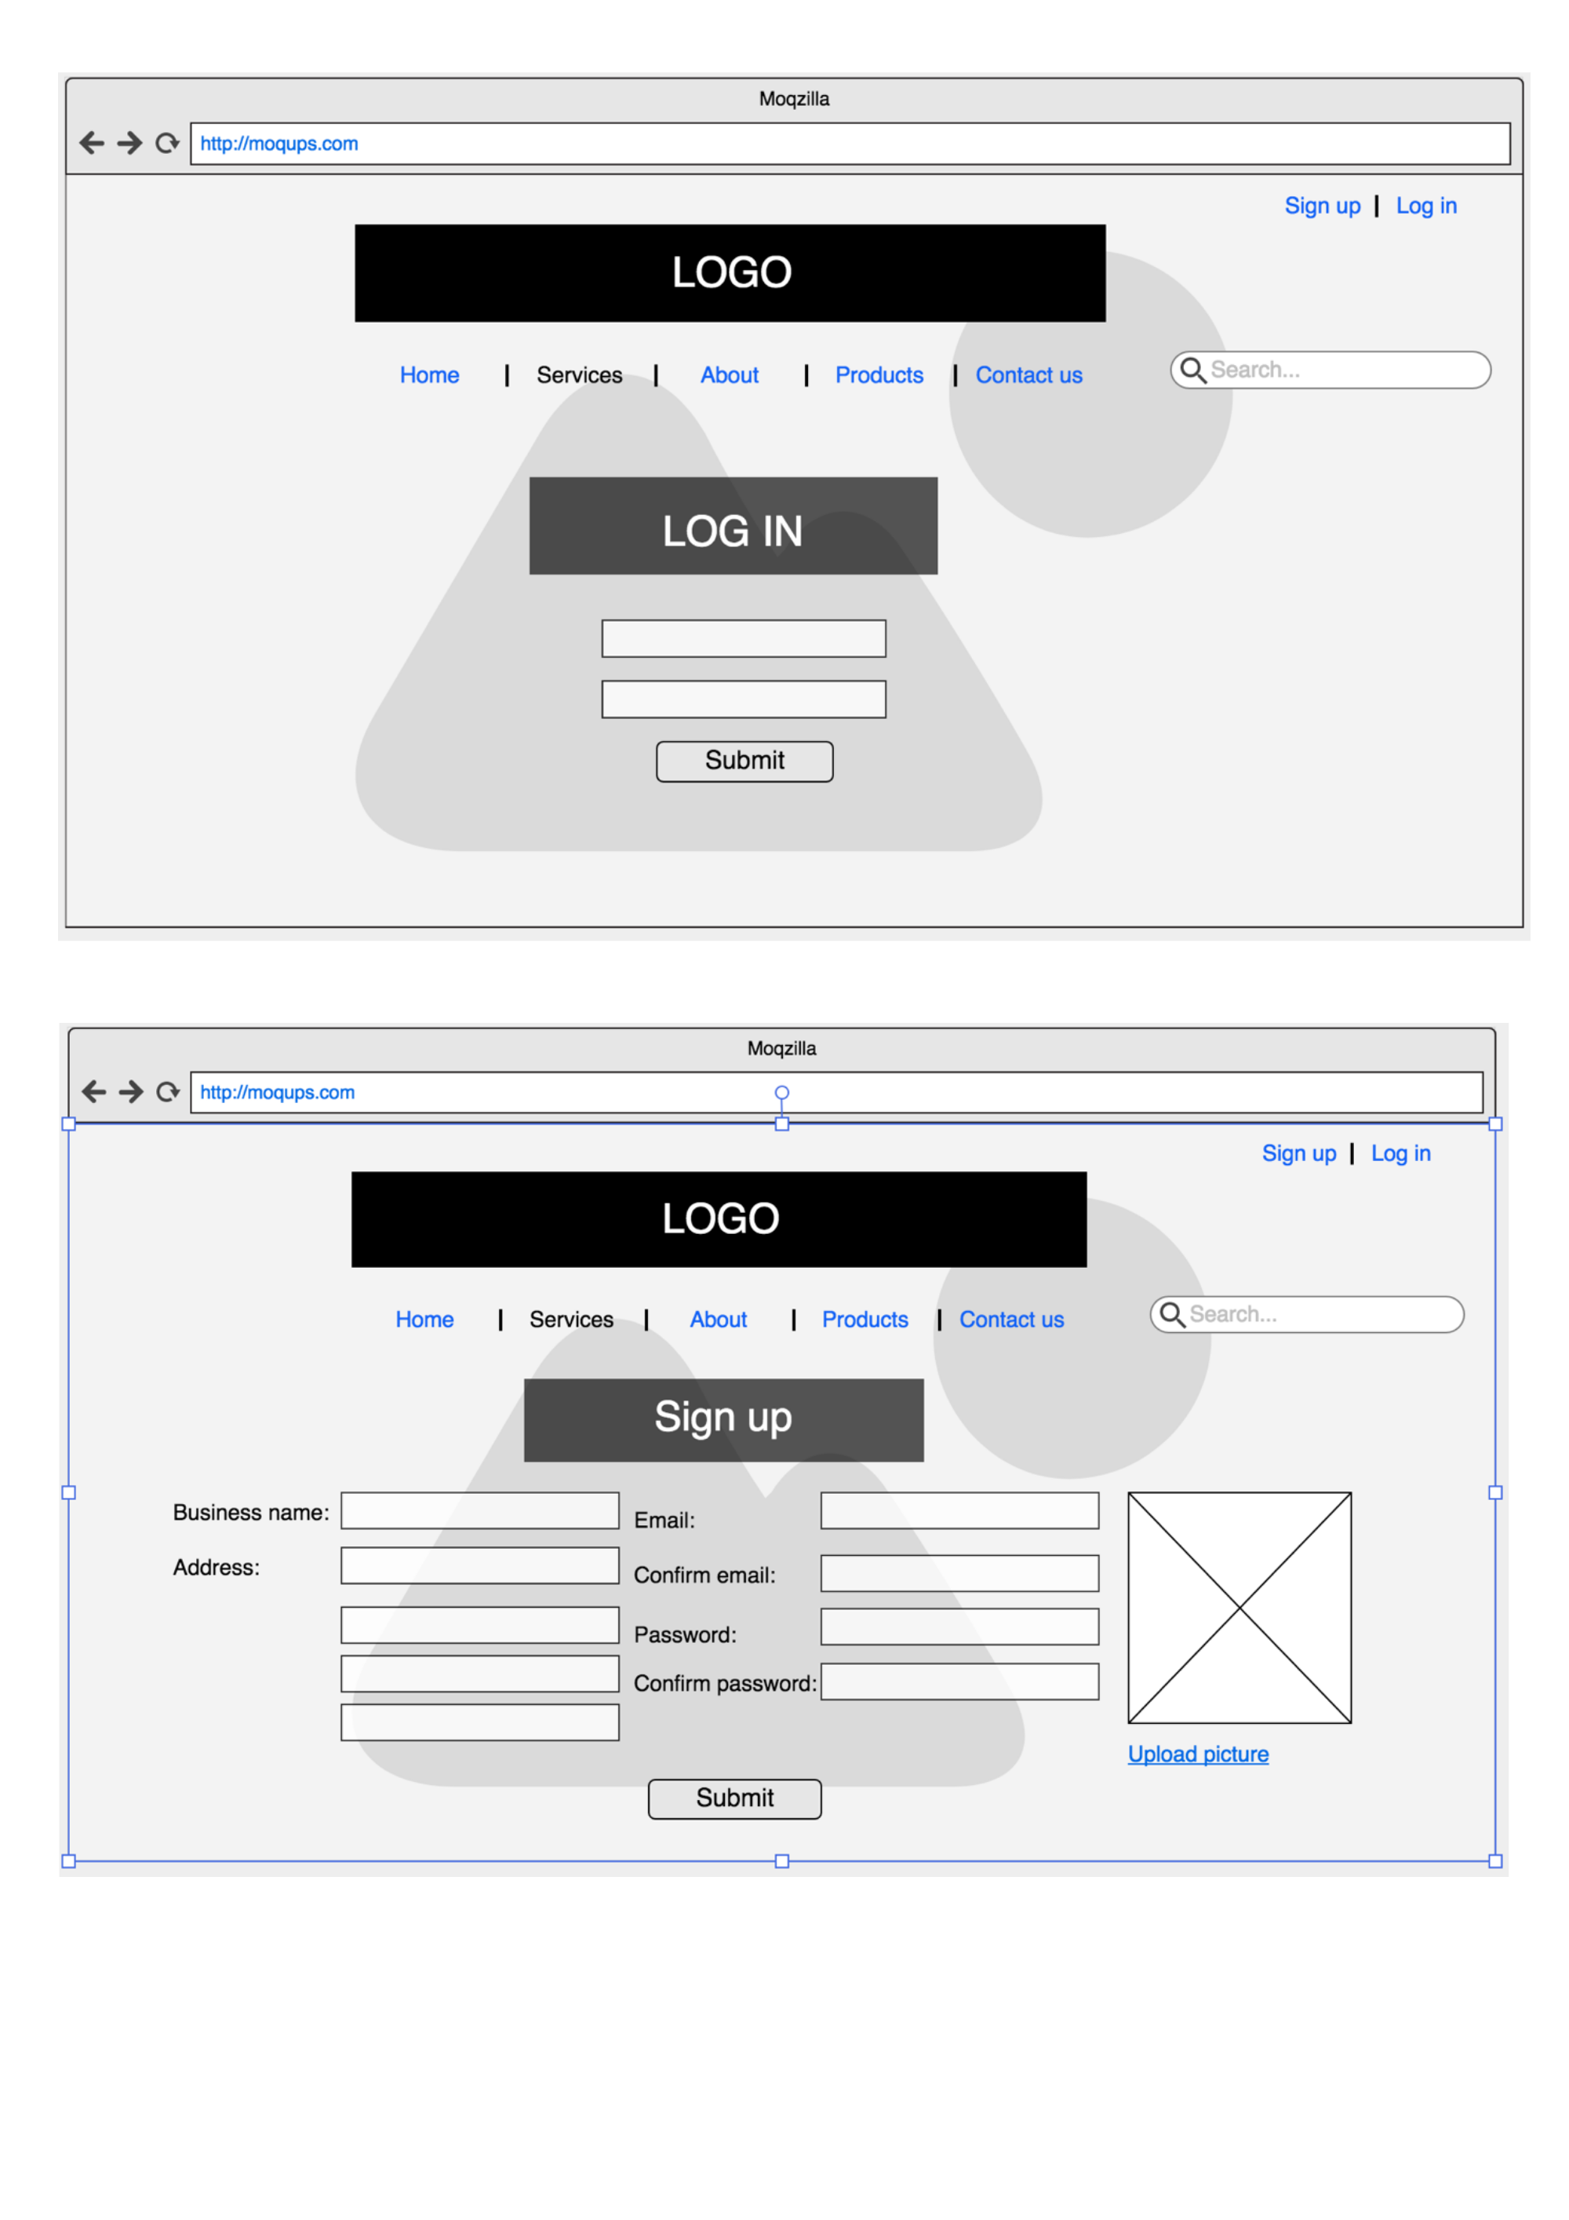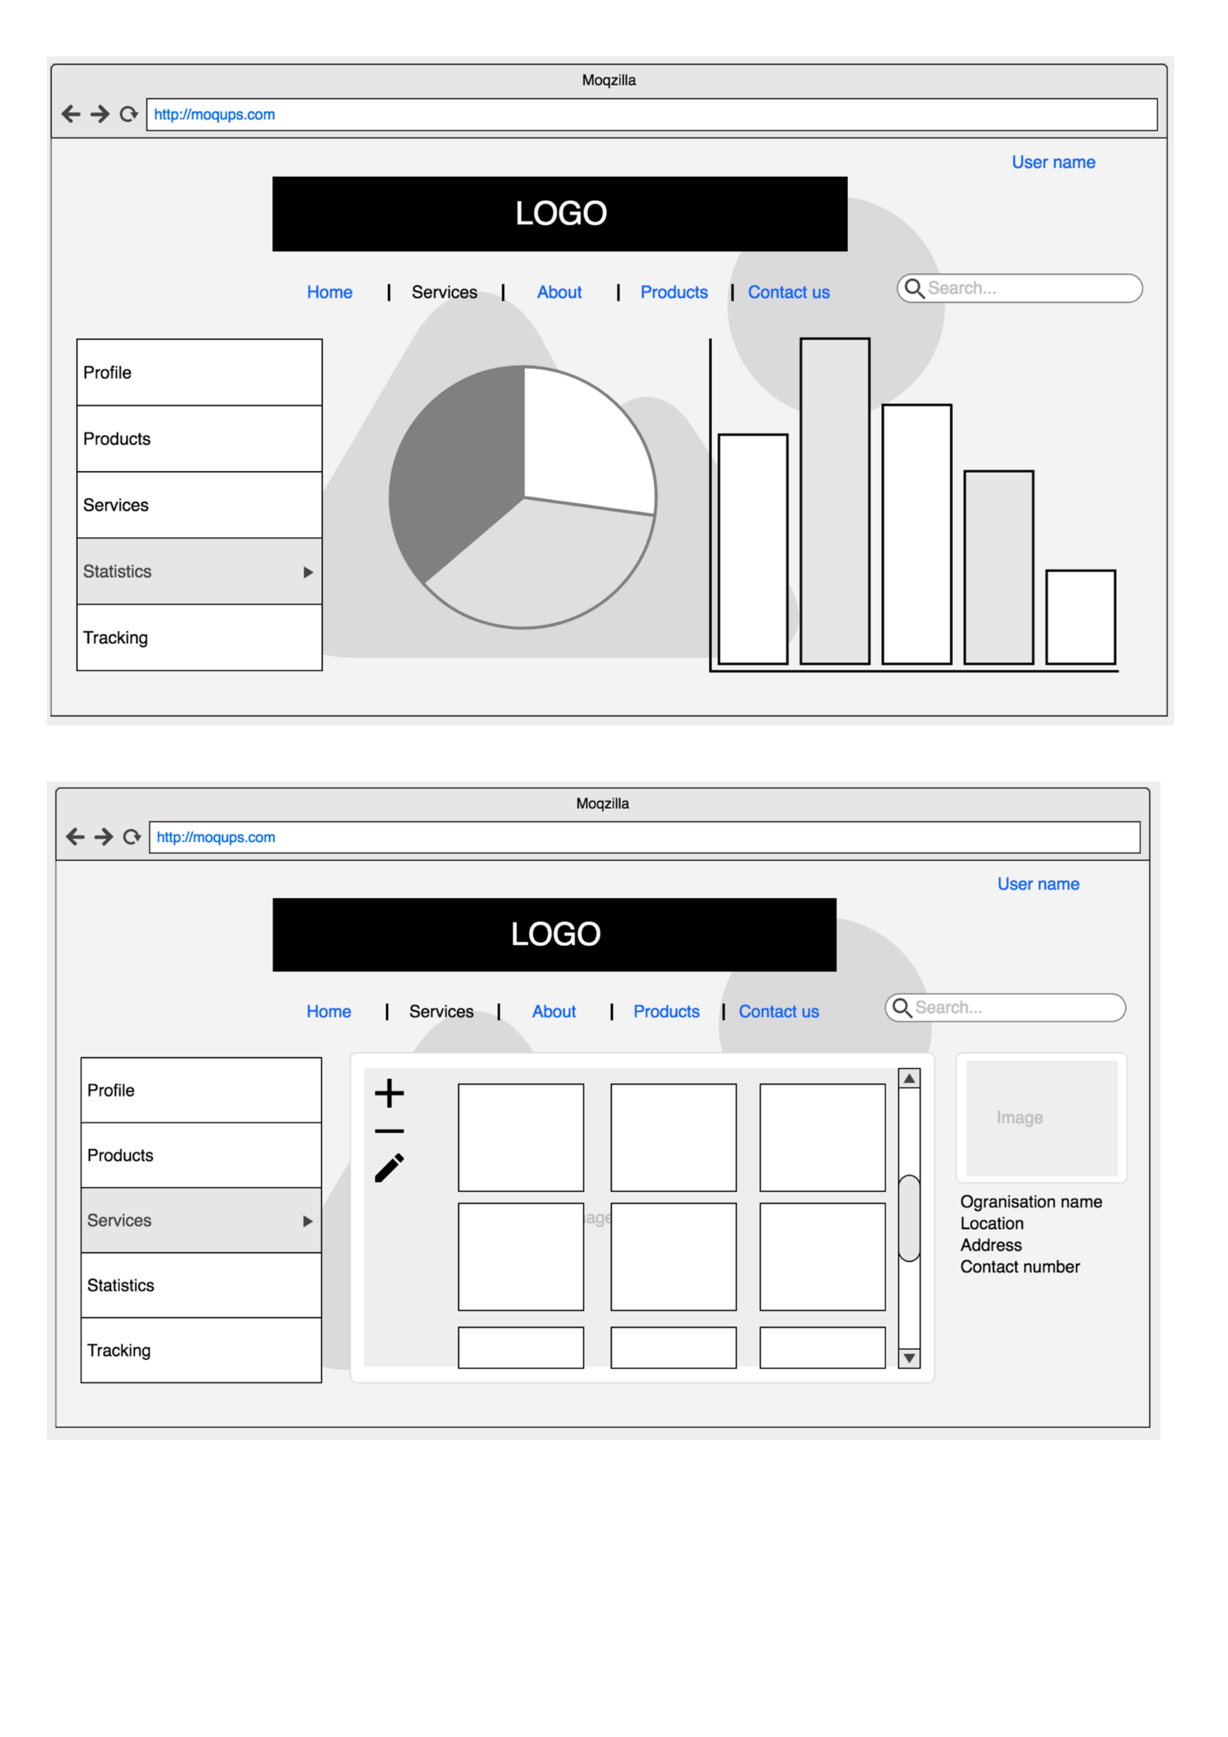

*Figure 12: Digital wireframes/prototypes.*

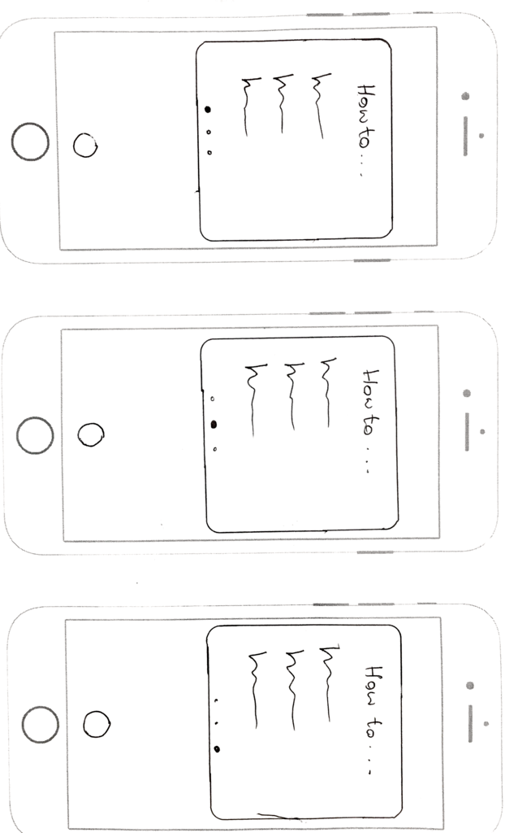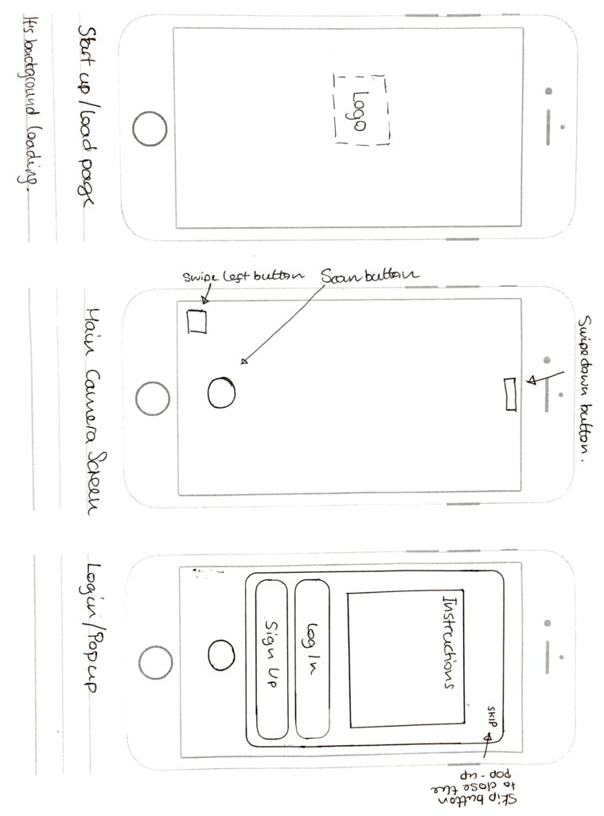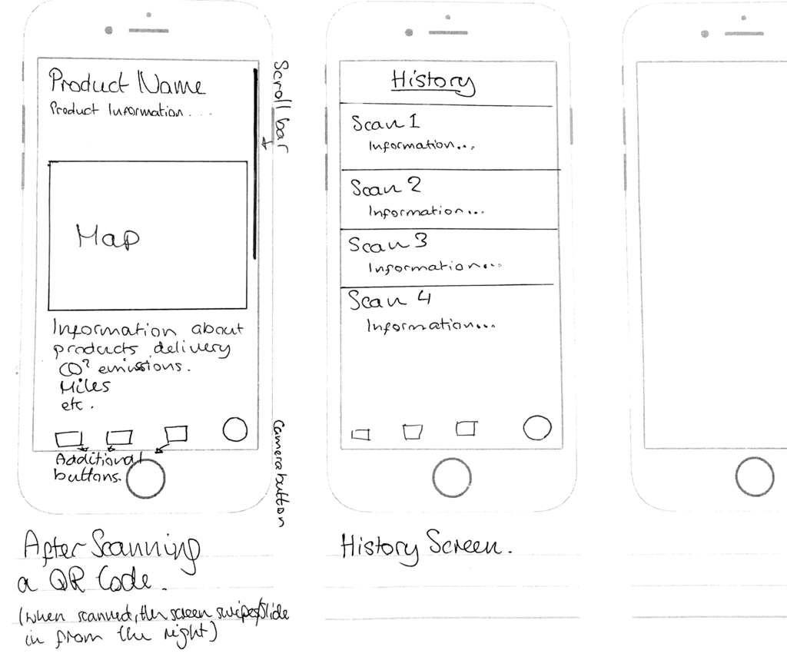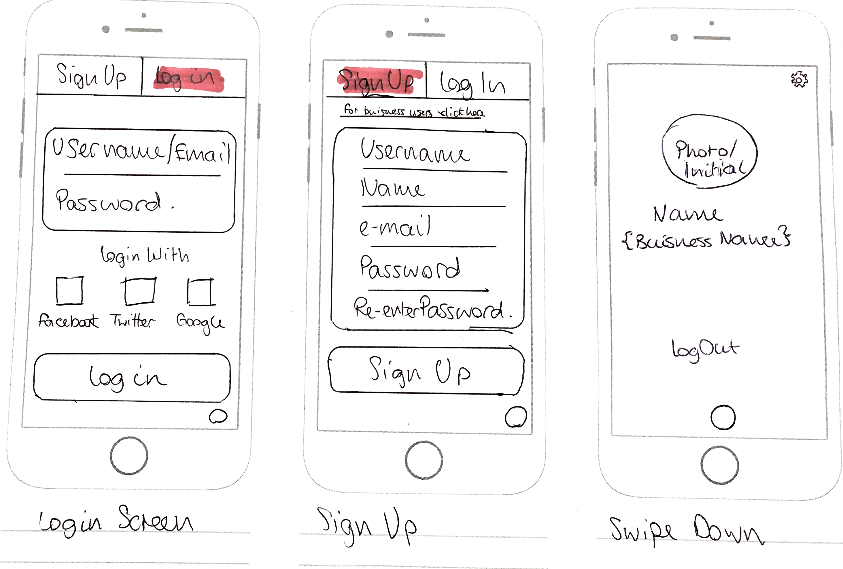

*Figure 13: Paper wireframes/prototypes for Mobile App.*

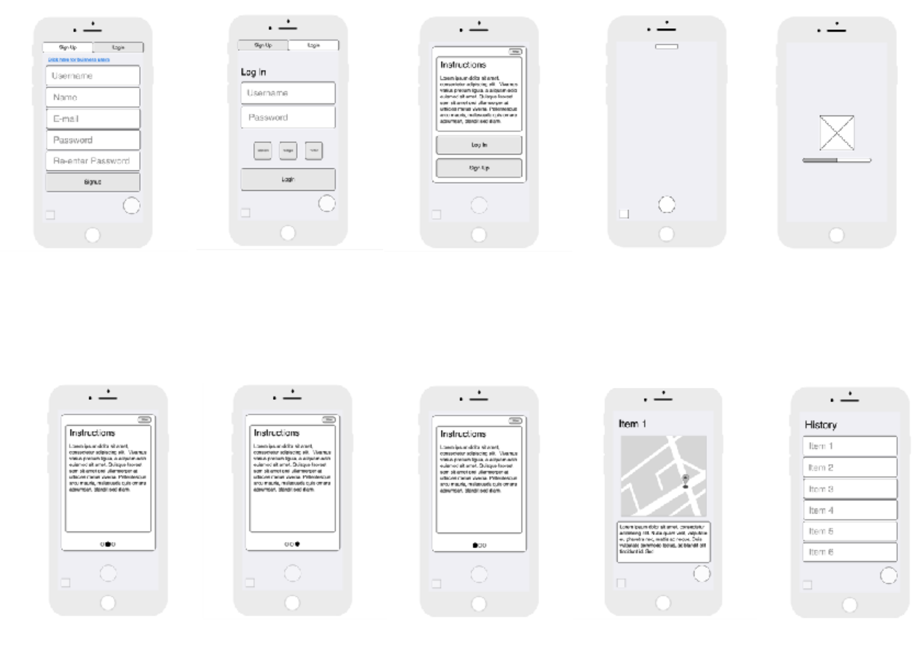

**Evaluation Plan:**

##Evaluation Plan:## Our aim is to find the right balance between writing code and testing. It is really important to give testing enough time and importance especially that this is a group project and each individual will write their own piece of code towards the end product. Leaving obvious bugs in the code is a waste of time and a waste of other people's time.

What we agreed on is this mix: 40% designing and writting code, 5% spent on code review and static code analysis, 25% spent on unit testing and integration testing and 30% on basic functionality testing and single performance user testing.

###1. Basic functionality testing:### Making sure that every button on the screen works and also making sure that every field that can have text as an input will work and not crash the software. The goal here is to not let other people touch our work if it's going to crash as soon as they enter their own name in the username field. We will have an API feature so it will be tested that the basic API functionality works well before submitting it for more intensive testing. ###2. Code review:### Before code review the basic functionality testing will be done. Everyone in the group will have to look at the code, even if it's not the code they wrote. Another pair of eyes looking at the source code can uncover a lot of problems. ###3. Static code analysis:### We are gonna use tools that will perform analysis on the source code without executing it. These static code analysis will look for weaknesses such as security vulnerabilities and potential concurency issues. ###4. Unit testing:### Each of us will write unit tests to make sure that the unit (be it method, class, or component) is working as expected and tested across a range of valid and invalid inputs. We can also work with mock objects and virtualized services. ###5. Single-user performance testing:### Single-user performance on the front-end and making sure the software is responsive when only they are using the system. If it's taking more than a few seconds to display the web page or pull the products from the database then the client-side code is slowing things down and has to be fixed.

**Computer Misuse Act 1990:**

**The Computer misuse act consists of 3 main offences:**

* -- Accessing computer material without permission, eg looking at someone else's files.
* -- Accessing computer material without permission with intent to commit further criminal offences.

**Access clearance must be set for staff, so that people with unauthorized access are unable to retrieve data and alter information or make changes towards them with criminal intent or harm.**

**The Data Protection act:**

* -- The Data Protection Act (DPA) is a law designed to protect personal data stored on computers or in an organised paper filing system. The act itself follow 8 different principles which are: Personal data shall be processed fairly and lawfully and, in particular, shall not be processed unless:
* -- Personal data shall be obtained only for one or more specified and lawful purposes, and shall not be further processed in any manner incompatible with that purpose or those purposes. Personal data shall not be transferred to a country or territory outside the European Economic Area unless that country or territory ensures an adequate level of protection for the rights and freedoms of data subjects in relation to the processing of personal data.

**Data related to the project may consist of personal information that of customer details, such as address information and locations in which they have shopped at before. Basic information that is anonymous does not require great amounts of security however personal data such as names and mobile numbers must be prioritised in terms of security at all times in order to abide by the laws.**

**Copyright act**

**Copyright gives the creators of some types of media rights to control how they're used and distributed. Music, books, video and software can all be covered by copyright law.**

In this instance we need to make sure that content or software used in the project has to be that of free licenced material or permission granted content to avoid issues. This can include designs such as logos, and other content.

**Appendix:**

**Functional Requirements for GeoFood Non-Consumer Mobile App:**

|  |  |  |  |
| --- | --- | --- | --- |
| **Requirement ID** | **Requirement Statement** | **Must/Want** | **Comments** |
| FR101 | Users shall be able to download the mobile app through an application store. The application shall be free to download. | Must |  |
| FR102 | The app shall notify users about new releases. Users shall download updates in the same way as they download the mobile application. | Must |  |
| FR103 | First-time user of the mobile application shall see the log-in page when he/she opens the application. | Must |  |
| FR104 | To be logged in the user shall provide username, password and click login. | Must | Database storing all accounts registered. |
| FR105 | The app shall send a request to the GeoFood webservice and authenticate users. | Must | Webservice communicates with our database and sends a response. |
| FR106 | The app shall display a response from the webservice with authentication status. | Must | Simple “success” or “wrong username/password” animation. |
| FR107 | The app shall store the log-in information on the phone and in the future the user should be logged in automatically. | Must |  |
| FR108 | The app shall let the user logout of their account. | Must |  |
| FR109 | The app shall display a menu with possible actions. | Must | “List of products”, “Add new product”, “Scan a QR Code”, “About us”, “Logout” |
| FR110 | Users shall be able to click buttons from the menu. | Must |  |
| FR111 | The app shall display detailed product descriptions consisting of name and location history. | Must |  |
| FR112 | The app shall organise the list of products by product name or ID. | Want |  |
| FR113 | The app shall have a functionality to delete products from the list. | Must |  |
| FR114 | The user shall be able to add new products and provide more information about them. | Must | Location, timestamp, device ID |
| FR115 | The app shall allow users to generate new QR Codes based on the given information. | Must |  |
| FR116 | The app shall allow the items in the catalogue to be searched. | Must |  |
| FR117 | The app shall allow users to scan QR codes on products. | Must |  |
| FR118 | The app shall allow users to update information about products. | Must |  |
| FR119 | Users shall be able to save QR Codes as a “png” or “pdf” file. | Must |  |

**Functional Requirements for Geofood Consumer Mobile App.**

|  |  |  |  |
| --- | --- | --- | --- |
| **Requirement ID** | **Requirement Statement** | **Must/Want** | **Comments** |
| FR001 | The app shall have a login screen where the users can login or register an account. | Must | Database storing all accounts registered. |
| FR002 | The app shall have a ‘skip’ option to carry on as a guest if they rather not register/login. | Must |  |
| FR003 | The app shall allow users to scan QR codes on products. | Must | Database storing all QR codes with information. |
| FR004 | After scanning a product, the app shall display information about the item. | Must | Database storing all information to do with a certain QR code. |
| FR005 | The app shall have a history tab for users that have logged in to view their previous scans. | Want | Database storing history of scans. |
| FR006 | The app shall let the user logout of their account. | Must |  |
| FR007 | The app shall allow the user to search for a product’s information. | Want | The user will search a catalogue or our database. |
| FR008 | The app shall have an ‘about us’ section telling the users about our app. | Must |  |
| FR009 | The app shall display a map when the user asks for transport information. | Must | The transport history will be stored in databases by the farmer/drivers. |
| FR010 | The app shall display a history tab where the user can see all their recent scans. | Want |  |
| FR011 | The app shall allow any logged in users to favourite an item. | Want |  |
| FR012 | The app shall display all the users’ favourites when requested. | Want |  |

**Functional Requirements for Geofood Website.**

|  |  |  |  |
| --- | --- | --- | --- |
| **Requirement ID** | **Requirement Statement** | **Must/Want** | **Comments** |
| FR201 | The website shall have a home page that lists the purpose of the organisation. | Must | A clean, professional page to display most of the information. |
| FR202 | The homepage shall have link to the relevant app stores to download the app on the users preferred device. | Must | Google Play, Apple Store |
| FR203 | The homepage shall also have a section dedicated to product statistics. | Want | Top scanned products, best rating, hype, feedback and so on. |
| FR204 | The website shall have a search function. | Want | Search for a specific product. |
| FR205 | The website shall have a Contact/Helpdesk page. | Must | Email, Phone, Live chat - Businesses will be able to enquire about signing up. Also help or support with the app or any inquiries about the products. |
| FR206(a) | The website will have a Login page for businesses. | Must | Businesses will be able to login and manage their profile and catalogue. |
| FR206(b) | The website will have a Login page for admins. | Must | Administrators will be able to create/delete and view every catalogue and to edit/add/delete and view the products history. |
| FR207 | The website shall have a Logout page. | Must | Users will be able to Logout of their accounts. |
| FR208 | The website shall be linked to a database. | Must | All catalogues, products, accounts and statistics will be pulled from said database. |
| FR209 | The website shall have an algorithm that will calculate how “good” a product is. | Want | It will take all the products’ attributes, travelled distance, pollution and so on that were inputted by the user and give it a rating out of 100%. |

**Food organization details:**

| **Companies or organisations** | **Name:** | **Detail/ info** |
| --- | --- | --- |
| Quality assurance international | **Executive Director:** Dr. Bernhard Url  **Senior Vice President:** Joe Smillie | **Fax:** 858-792-8665  **Fax:** 858-792-8665 |
| Foods standard agency | **CEO:** Catherine Brown | **Linkedin:**<https://www.linkedin.com/in/catherineb201/> |
| European food safety authority | **Executive Director:** Dr. Bernhard Url | **E-mail:**  [Bernhard.Url@efsa.europa.eu](mailto:Bernhard.Url@efsa.europa.eu) |

**List of farmer's markets in London:**

| **Companies or organisations** | **Name:** | **Detail/ info** |
| --- | --- | --- |
| Surrey Docks farm London | **Farm Manager:** Gemma hooper | **E-mail:**  [Gemma@surreydocksfarm.org.uk](mailto:Gemma@surreydocksfarm.org.uk) |
| London Farmers market |  | **E-mail:**  [info@lfm.org.uk](mailto:info@lfm.org.uk) |
| Organic farm foods | **CEO:** Adam Wakeley | **Linkedin:**  <https://www.linkedin.com/in/adamwakeley-0249975/> |
| GrowUp urban | **Founder:** Kate Hofman | **Linkedin:**  <https://www.linkedin.com/in/katehofman/> |
| Doves farm foods ltd |  | **E-mail:**  [mail@dovesfarm.co.uk](mailto:mail@dovesfarm.co.uk)  **Phone**  +44 (0)1488 684 880 |
| Cobrey farms |  | **E-mail:**  [office@cobrey.co.uk](mailto:office@cobrey.co.uk) |

**List of "Halal" slaughterhouses in UK:**

| **Companies or organisations** | **Name:** | **Detail/ info** |
| --- | --- | --- |
| Gafoor Pure halal |  | **E-mail**  [gppreception@gafoor.co.uk](mailto:gppreception@gafoor.co.uk) |
| Foods standard agency | **Managing Director:** Catherine Brown  **Operations Manager:** David Jasper | **E-mail:** [Keith@jasperslamb.co.uk](mailto:Keith@jasperslamb.co.uk)  [David@jasperslamb.co.uk](mailto:David@jasperslamb.co.uk) |
| Randall parker foods |  | **E-mail:**  [enquiries@rpfg.co.uk](mailto:enquiries@rpfg.co.uk) |
| Rhug Estate ltd Rhug organic |  | **E-mail:**  [contact@rhug.co.uk](mailto:contact@rhug.co.uk) |

**List of Abattoir in UK**

| **Companies or organisations** | **Name:** | **Detail/ info** |
| --- | --- | --- |
| Newman’s Abattoir |  | **E-mail**  [enquiries@newmansabattoir.co.uk](mailto:enquiries@newmansabattoir.co.uk) |
| C Snell Wholesale Butchers |  | **E-mail:**  [info@csnellwholesale.co.uk](mailto:info@csnellwholesale.co.uk) |
| Tideford Abattoir |  | **E-mail:**  [tidefordabattoir@btconnect.com](mailto:tidefordabattoir@btconnect.com) |
| Sandyford Abattoir |  | **E-mail:**  [enquiries@johnscottmeat.com](mailto:enquiries@johnscottmeat.com) |

**List of Supermarkets**

| **Companies or organisations** | **Name:** | **Detail/ info** |
| --- | --- | --- |
| Sainsbury's | **Chairman of J.Sainsbury plc:** David Tyler  **CEO:** Mike Coupe   John Rogers | **Linkedin**  <https://www.linkedin.com/in/davidtyler-696b643/>  **E-mail**  [mike.coupe@sainsburys.co.uk](mailto:mike.coupe@sainsburys.co.uk)  **Linkedin**  <https://www.linkedin.com/in/johnrogers-77b1964/> |
| Tesco | **Executive chairman:** John Allan  **CEO:** David lewis | **Linkedin:**  <https://www.linkedin.com/in/johnallan-01b53013/> |
| Morrisons | **Chairman:** Andrew Higginson  **CEO:** David Pots | **Linkedin:**  <https://www.linkedin.com/in/andyhigginson-a3b97b118/>  **Email:**  [david.potts@wmmorrisons.co.uk](mailto:david.potts@wmmorrisons.co.uk) |
| Marks and Spencer | **Chairman:** Archie Norman  **CEO:** Steve rowe | **Linkedin:**  [https://www.linkedin.com/in/archienorman-](https://www.linkedin.com/in/archienorman-1bb13a20/) |

# References:

## Books

* Ricketts, Ian. Managing Your Software Project : a Student's Guide. London, Springer, 1998.

## Online articles

* Qr-code-generator.com. (2017). QR Code Basics. [online] Available at: <http://www.qr-code-generator.com/qr-code-marketing/qr-codes-basics/> [Accessed 29 Oct. 2017].

## Websites

* Advantages and Disadvantages of QR code. 2017. Advantages and Disadvantages of QR code. [ONLINE] Available at:<http://www.estateqrcodes.com/advantages-disadvantages.html>. [Accessed 30 October 2017].
* Brands, Innovation and Creative Technologies. 2017. The Problem with QR Codes | Brands, Innovation and Creative Technologies. [ONLINE] Available at: <https://brandsandinnovation.com/2011/01/09/the-problem-with-qr-codes/>. [Accessed 30 October 2017].
* Joris. 2017. 3D printed QR code stamps - Shapeways Magazine. [ONLINE] Available at: [https://www.shapeways.com/blog/archive](https://www.shapeways.com/blog/archives/250-3d-printed-qr-code-stamps.html)